

MACHINE LEARNING METHODS FOR CREDIT CARD FRAUD DETECTION USING IMBALANCED TRANSACTION DATA
Student Name: Akshaya Chirra
Student No: A00049743

Table of Contents
Table of Contents 2
1. Chapter 1: Introduction 4
1.1 Background and Context 4
1.2 Research Problem 5
1.3 Aim and Objectives 6
1.4 Research Question 6
1.5 Significance of the Study 7
1.6 Structure of the Dissertation 7
2. Chapter 2: Literature Review 8
2.1 Credit Card Fraud: Concepts and Types 8
2.2 Traditional Fraud Detection Methods 8
2.3 Machine Learning Approaches in Fraud Detection 9
2.3.1 Supervised learning techniques 9
2.3.2 Unsupervised learning techniques 10
2.3.3 Ensemble and Hybrid Models 10
2.4 The Challenge of Imbalanced Data 11
2.5 Techniques for Handling Imbalanced Data 11
2.6 Evaluation Metrics in Fraud Detection 12
2.7 Real-Time Fraud Detection Challenges 13
2.8 Comparative Analysis of Existing Studies 15
3. Chapter 3: Research Design and Methodology 18
3.1 Research Diagram 18
3.1 Research Design 19
3.2 Data Source and Description 20
3.3 Data Analysis 20
3.4 Data Preprocessing 21
3.5 Exploratory Data Analysis (EDA) 21
3.6 Feature Engineering and Data Splitting 22
3.7 Machine Learning Models 22
3.8 Model Evaluation Metrics 23
3.9 Reliability and Validity 24
3.10 Advantages and Limitations of Methodology 24
3.11 Ethical Considerations 25
4. Chapter 4: Results, Analysis and Evaluation of Findings 26
4.1 Data Relevancy 26
4.2 Reliability and Validity of the Source 26
4.3 Results and Analysis 27
4.4 Key Findings 49
4.5 Discussion on Findings 51
5. Chapter 5: Conclusions and Recommendations 53
5.1 Conclusion 53
5.2 Linking with Objectives 53
5.3 Limitations 55
5.4 Future Scope 56
5.5 Recommendations 57
References 59

1. Chapter 1: Introduction

1.1 Background and Context
It has been underscored from the background research that the digital payment system has been rising in a coharent manner as well as transformed the global financial environment. The research states that in the last ten years, technological development in financial technology (FinTech) and e-commerce websites, as well as online banking services, has accelerated the growth of electronic transactions. The convenience and accessibility of credit cards, as well as seamless integration with digital commerce systems, have ensured that credit cards have remained one of the most used modes of payment. Also, these digital transactions have boosted the chances of credit card fraud activities, and it has become one of the biggest problems that financial institutions, merchants, and consumers have faced because of this cogent growth in digital transactions (Dornadula and Geetha, 2019). Mainly, the credit card fraud occurs when someone utilises a credit card or card-related information without the permission of the owner to obtain financial gain. The fraudulent transactions may occur in various ways, such as card information theft, phishing, data breaches, and card-not-present transactions, which are usually involved in online shopping. As digital payment systems keep evolving, fraudsters are always coming up with innovative ways to exploit the vulnerabilities of financial infrastructures. This creates pressure for financial institutions to ensure that they develop sophisticated fraud detection systems that can detect suspicious transactions as soon as they occur and in the most accurate way. Credit card fraud has huge financial consequences. Due to the growth in electronic transactions, the amount of money lost through fraud is rising worldwide, and financial institutions face direct financial losses in addition to reputational losses and regulatory penalties. Besides financial losses, fraudulent transactions may damage the customer confidence in online payment systems and affect the sustainability of electronic commerce in the long run (Warghade et al., 2020). This is why the use of effective fraud detection systems has become a high priority for contemporary financial services.
It is also discovered from the journal analysis that the traditional fraud detection system mainly depends on the rule-based methods and manual monitoring. These systems had pre-programmed rules that indicated flag transactions depending on the amount of the transaction, location of the transaction or spending frequency. Although rule-based solutions offered a straightforward form of protection, they are not very effective in responding to new and emerging fraud trends. With the traditional method, the system is not able to detect starategical frauds while fraudsters alter their methods to bypass static rules. To address these shortcomings, machine learning (ML) has become an effective approach to fraud detection. Machine learning algorithms can analyse a huge amount of transaction data and detect intricate patterns that differentiate between legitimate transactions and fraudulent. Machine learning models are able to learn new fraud trends from the historical data, which cannot be accomplished by traditional rule-based systems (Makki et al., 2019). This coherent adaptability allows financial institutions to develop more scalable and efficient fraud detection systems that can track millions of transactions in real time. Although those are the benefits, the major key issues of implementing machine learning in fraud detection are the extremely imbalanced distribution of transactions. The critical analysis of secondary data analysis defines that in real-world data, fraudulent transactions are very small proportion of total transactions, such as less that 1%. This extreme imbalance in classes renders it hard to predict the fraud-related transactions using machine learning models, which support the majority class of genuine transactions. Also, coherent methods like “resampling techniques, oversampling, undersampling, and Synthetic Minority Over-sampling Technique (SMOTE)” are frequently used to enhance the performance of the model (Gupta et al., 2023). Due to the increasing volume of digital payments and the ongoing problem of fraud, there is a strong necessity to systematically consider machine learning methods that will be effective in resolving the problem of class imbalance. The study is thus going to examine and compare various machine learning models and imbalance handling approaches to enhance the detection of fraudulent credit card transactions.

1.2 Research Problem
The credit card fraud detection can be developed as a binary classification problem, whereby every transaction is categorised as legitimate or fraudulent. Though this formulation may seem straightforward, the extreme imbalance of legitimate and fraudulent transactions presents challenges for machine learning models. Traditional classification algorithms are usually formulated in such a way that they maximise the total accuracy. Also, when applied to unbalanced data, accuracy might not state the real effectiveness of a model. The most important class in fraud detection scenarios is the minority class or fraudulent transactions. Early detection of such rare events is important to avoid losses of money and protect customers from unauthorised transactions (Wijaya et al., 2024). Also, due to the infrequent occurrence of fraudulent transactions, machine learning models might fail to acquire meaningful patterns that are related to fraud. Consequently, models can achieve high accuracy and have low recall, i.e. numerous fraudulent transactions can go unnoticed. The trade-off between false positives and false negatives is also another issue. False positives can happen where genuine transactions are mistakenly classified as fraudulent transactions, and this can frustrate customers and disrupt the usual operation of transactions. On the other hand, false negatives are instances of fraudulent transactions being considered as legitimate and as such, a direct financial loss is incurred. To design a fraud detection system, the researcher must therefore take this trade-off thoughtfully in order to balance between detection accuracy and operational practicability. Although the research on machine learning-based fraud detection has been increasing, comparative studies and analysis of various algorithms and imbalance management methods in a consistent experimental setting remain necessary (Warghade et al., 2020). The knowledge of the performance of various machine learning models in extreme class imbalance conditions may offer important insights to financial institutions interested in deploying effective fraud detection systems.

1.3 Aim and Objectives
Aim
The main aim of developing this dissertation is to design and evaluate various machine learning models to detect credit card fraud based on imbalanced transaction data, especially focusing on the effectiveness of imbalance handling techniques and appropriate evaluation metrics.
Objectives
- To critically analyse various kinds of published journal articles and academic literature related to credit card fraud detection, to underscore the innovation of credit card fraud detection with imbalanced data and determine gaps which can support future analysis.
- To coherently analyse the effects of the imbalance of classes on the performance of machine learning classification models.
- To develop and contrast various machine learning models for fraudulent credit card transaction detection.
- To evaluate the model performance with the help of various performance measure metrics such as accuracy, precision, recall and F1 score.
- To determine the best modelling method, using empirical experimental findings.

1.4 Research Question
The research question that will guide the research is as follows,
- What are the effective ways to design and evaluate machine learning models to identify fraudulent credit card transactions in highly imbalanced datasets?
This question will deal with the technical challenges that are to be encountered by the imbalance of data, as well as with the practical considerations that are to be taken into account when implementing the systems of fraud detection in financial institutions.

1.5 Significance of the Study
The results of this study show theoretical and practical implications. Academically, the research contributes to the literature on machine learning applications in financial fraud detection, which is still growing. Through a methodical evaluation of various algorithms and imbalance management methods, the study offers insights into the effectiveness of various modelling techniques to use in real-world data (Makki et al., 2019). Also, the findings can be used by financial institutions to boost their fraud detection models to determine effective machine learning methods that can balance the detection and operation efficiency. The improved fraud detection systems will help to limit financial losses, accelerate customer trust, and develop safer digital payment systems.

1.6 Structure of the Dissertation
Chapter 1: Introduction
In this section, the researcher outlines the background, context, rationale, aim, objective and research question.
Chapter 2: Literature Review
This section is developed to critically analyse various kinds of published journal articles and academic literature related to credit card fraud detection, to underscore the innovation of credit card fraud detection with imbalanced data and determine gaps which can support future analysis.
Chapter 3: Research design and methodology
This chapter will show research design, dataset, data preprocessing steps, machine learning models, and evaluation methods.
Chapter 4: Results, analysis and evaluation of findings
This chapter will develop to show the implications of technical implementation as well as define the best machine learning models for determining fraud with imbalanced data.
Chapter 5: Conclusions and recommendations
In this chapter, the researcher will underscore the major findings of the study and deliver coherent recommendations for future research and practical implementation for fraud detection systems.

2. Chapter 2: Literature Review
The critical analysis of journals and background research states that the high use of the digital payment system has boosted the efficiency of the financial transactions, as well as developed major risks for fraudulent activities, such as credit card fraud. In this chapter, the researcher critically analyses various kinds of published journal articles from the Google Scholar database to underscore the technological innovation in the credit card fraud detection via imbalanced data and discover major research gaps, which can accelerate the efficiency of future work. With increased digitalisation of financial systems, the size and speed of transaction data keep increasing, and the traditional fraud detection methods are becoming less effective. As a result, machine learning (ML) has become one of the most popular methods of identifying fraudulent transactions because it can handle huge datasets and determine convoluted trends. The review is organised based on major themes and an analysis of published papers. The major themes are traditional methods of fraud detection, machine learning methods, the problem of class imbalance, methods of dealing with imbalanced data, and measures of evaluation adopted in the system of fraud detection. The chapter has also established research gaps that explain why the current study is required.

2.1 Credit Card Fraud: Concepts and Types
The research has stated that credit card fraud is directed to unauthorised access of credit card information and using it to gain monetary gains. Dornadula and Geetha (2019) stated that fraud can be developed by different mechanisms, which are physical theft, identity theft, phishing attacks, and data breaches. Card-not-present (CNP) fraud is one of the most common and mainly ensues during online transactions where the physical verification is missing. According to Warghade et al. (2020), fraud may be divided into two groups: offline and online fraud. Offline fraud entails the physical utilisation of stolen cards, whereas online fraud entails the utilisation of digital transactions with the use of stolen card information. As e-commerce expands, online fraud has also been increasingly dominant and difficult to recognise. One of the major characteristics of credit card fraud is that it is dynamic and changing in nature. Fraudsters keep upgrading their methods to evade fraud detection systems, and the detection of fraud has become a moving target. This dynamism requires adaptive and intelligent systems that can learn based on new data patterns.

2.2 Traditional Fraud Detection Methods
The detection systems used to detect fraud at the initial stages were mainly based on manual intervention and rule-based detection. These systems have set regulations like transaction alerts, geographical anomalies, and suspicious spending patterns that would determine suspicious transactions. It has been underscored from the research that rule-based systems are easy to understand and interpretable, but they have a number of weaknesses. To start with, they are not dynamic, which underscores that the system is not able to determine new fraud patterns without human intervention or manual updates. Also, they contain many false positives that can bother customers and decrease the level of confidence in the system. It is also analysed from research that they cannot scale to process large amounts of transaction data. According to Makki et al. (2019), the traditional systems are unable to track sophisticated patterns of fraud since they apply linear and simplistic rules. The rule-based systems are becoming ineffective as fraudsters are increasingly using more advanced methods. Such limitations have led states to use machine learning methods, which are flexible, scalable, and deliver predictive accuracy.

2.3 Machine Learning Approaches in Fraud Detection
The research has stated that the machine learning modelling shows coharent effectiveness in credit card fraud detection because it has the ability to analyse a huge amount of past transaction data as well as discover trends which have helped to discern legitimate cases from fraudulent cases. The learning effectiveness and data nature have been divided the machine learning mdoeling in three categories, which are supervised, unsupervised, and hybrid methods.

2.3.1 Supervised learning techniques
The critical analysis of journals states that supervised learning techniques has been used by several authors for detecting credit card fraud. Mainly, the labelled datasets are needed for training the supervised models as well as classifying transactions as legitimate or fraudulent. With the help of this method, the model can learn the aspects of fraudulent behaviour as well as use this understanding in the test data to make accurate predictions. It is also defined in the research that various algorithms, such as “Logistic Regression (LR), Decision Trees (DT), Random Forest (RF), Support Vector Machines (SVM), K-Nearest Neighbours (KNN), and Naïve Bayes (NB)”, are to be used for classifying fraud and legitimate cases. Dornadula and Geetha (2019) state that the ML models like Random Forest and Logistic Regression has been shows cogent accuracy in fraud detection because of their capability to accurately process big datasets and define convoluted relationships. The journal analysis also states that the random forest is an ensemble method which is precise for eliminating the overfitting and shows efficiency in determining nonlinear realationship in between variables. Also, with various kinds of effectiveness their are some limitations such as supervised models dependent on high-quality labelled data, which gathering is very expensive anb consume time. The critical analysis states that these models are prone to class imbalance, which can cause biased predictions for the majority (non-fraudulent) class.

2.3.2 Unsupervised learning techniques
Also, unsupervised learning techniques are mainly used when the labelled data is not available. These techniques determine variations from transaction patterns that might point to fraudulent activity. The journal analysis states that the cogent unsupervised methods are Autoencoders and Isolation Forest, as well as clustering methods like K-means. These models are accurate for determining fraud patterns that are yet unseen and do not require labelled data. Also, their practical applicability has decreased due to their lack of precision and tendency to produce more false positives. It is discovered from the literature that unsupervised approaches are coherent for anomaly detection, but Makki et al. (2019) claim that when labelled datasets are available, they serve less cogently than supervised methods. This states the effectiveness of assigning accurate methods according to data availability and problem scenario.

2.3.3 Ensemble and Hybrid Models
As per Karthik et al (2022), the ensemble learning techniques have gained tremendous popularity for credit card fraud detection, because they have the capability to accelerate predictive accuracy via integrating various models. The author also states that the ensemble methods has effectiveness than single classifiers, because this method merges the output of various base learners and develops accurate and trustworthy predictions. Various efficient ensemble techniques are bagging, boosting, and stacking. The Random Forest is a bagging method which has the ability to decrease variance by training various data subsets. Gradient Boosting Machines (GBM) is a boosting techniques that help in decreasing bias and boosting the accuracy of weak learners. The author Btoush et al. (2025) underscores that the stacking techniques mainly involve merging predictions from various models as well as uses meta-learner to accelerate performance. It has been underscore from the Khalid et al. (2024) that the author used Random Forest and Gradient Boosting Machines (GBM) for fraud detection. The model comparison analysis shows that the Random Forest, such as an ensemble method outrperforms “Support Vector Machine (SVM), K-Nearest Neighbour (KNN)”, which states accurate classification of frauds. Also, the analysis states the author uses “under-sampling and the Synthetic Over-sampling Technique (SMOTE)” to balance the data. Here, the random forest is selected as the best model because it has the ability to decrease overfitting and handle high-dimensional data and convoluted feature relationships. Also, Du et al. (2023) state that GBM accelerate predictive accuracy via error correcting of earlier models as well as its cogent for determining major fraud patterns. The ensemble method boosts the model's generalisation power via bias and variance balancing, and achieves coherent performance compared to unified models. Wijaya et al. (2024) state that ensemble and hybrid models show volumetric performance and are better than single model approaches. This demonstrates the volumetric necessity of ensemble and hybrid models in creating effective fraud detection systems.

2.4 The Challenge of Imbalanced Data
The coherent analysis of various journal articles and practical implementation states that the class imbalance in credit card fraud data is a major problem, because the publicly available dataset has only 1% of fraudulent transactions. These types of data imbalance have been affecting the ML models performence. While the pipeline is coherent, the model mainly tends to be biased towards legitimate transactions, as well as achieving less accuracy for detecting fraud cases (Warghade et al., 2020). Also, it is evident from the research that an imbalance in the target variable affects accuracy, such as when the model has been achieving high accuracy, but the classification report underscores that the model only predicts legitimate cases and left to determine fraud cases. Another challenge is less generalisation, which states that the model faces difficulties in learning major patterns from the 1% of fraud data. The authors Breskuvienė and Dzemyda (2024) underscore that the traditional classification models show less effective performance for fraudulent transactions. Also, Singh, Ranjan and Tiwari (2022) state that high class imbalance is a central problem that diminishes the model performence and it is very beneficial to use accurate data balancing techniques to solve this problem. It can be concluded that eliminating the problem of class imbalance with appropriate data balancing techniques is necessary for develop trustworthy and trusted fraud detection system.

2.5 Techniques for Handling Imbalanced Data
The research has underscored that the authors propose and use various kinds of techniques for eliminating the class imbalance problem from credit card fraud detection because it has a coherent impact on the performance of ML models. The journal analysis defines that the data-level techniques have been used to modify the dataset as well as balance the classes. Also, another method, oversampling techniques, is mainly used to accelerate the minority class instances. The various authors justified that the Synthetic Minority Over-sampling Technique (SMOTE) is a cogent method that creates synthetic data with the help of interpolating in existing minority samples. The critical analysis of journals shows SMOTE has the capability to accelerate the model accuracy, recall and F1-score (Gupta et al., 2023). It is also discovered that oversampling causes overfitting when the synthetic instances fail to correctly mirror real-world patterns. Also, comparing oversampling with the undersampling, we can say that the undersampling decreases the majority class samples to balance the datasets. This method has cogent effectiveness for boosting computational efficiency as well as model concentration on the minority class, which can compel loss of useful information (Dornadula and Geetha, 2019). In order to eliminate the sampling issues limitation, author Warghade et al. (2020) introduce hybrid sampling techniques which have helped to merge oversampling and undersampling as well as deliver an accurate trade-off for bias and variance. It can be concluded that with the help of hybrid sampling techniques, the author can boost the performance of fraud detection.

2.6 Evaluation Metrics in Fraud Detection
The journal analysis states that the choice of suitable evaluation metrics is an important segment for credit card fraud detection, especially in the case of highly imbalanced transaction data. Fraudulent transactions in such datasets are a very low percentage of the overall data, so the traditional evaluation measures like accuracy are not reliable and misleading. A model can be very accurate just by predicting all the transactions as legitimate and failing to determine actual cases of fraud, thus making it unsuitable in the real world. To overcome this shortcoming, researchers state the need to use class-sensitive measures like precision, recall, and F1-score. Precision is used to determine the fraction of fraudulent transactions that are correctly identified in all the fraudulent transactions that have been predicted, and recall is used to determine the ability of the model to identify the actual fraud cases. Recall is also beneficial for fraud detection because false negatives (due to missing fraudulent transactions) can be very costly. It has been underscored from the literature analysis and from practical knowledge that if recall is increasing, then it decreases precision as well as causes false positives. This trade-off between recall and precision requires the usage of the F1-score, which gives a balanced measure by calculating the harmonic mean of precision and recall.
Along with these measures, curve-based evaluation measures, like ROC-AUC (Receiver Operating Characteristic Area Under Curve) and PR-AUC (Precision Recall Area Under Curve), are popular. ROC-AUC also measures the capability of a model to differentiate the classes by plotting the true positive rate versus the false positive rate. A number of studies claim that ROC-AUC can be overly optimistic on highly imbalanced datasets since it is affected by the high number of true negatives. PR-AUC, on the other hand, is thought to be more suitable in detecting fraud since it concentrates on the minority (fraudulent) group. It measures the correlation between accuracy and recall at various classification levels, which is more representative of model performance in unbalanced situations. Recent studies point out that PR-AUC and recall-based measures provide a better measure of fraud detection models than accuracy and ROC-AUC. Also, the evaluation based on the use of confusion matrices is also frequently employed to offer in-depth information about the performance of a model, such as true positives, false positives, true negatives and false negatives. This will enable the practitioners to know more about the trade-offs between fraud detection and false alarms. Other studies also use more sophisticated measures like the Matthews Correlation Coefficient (MCC) and G-Mean to give a more detailed analysis in the case of imbalanced metrics. Although there are several evaluation measures available, no universally accepted standard for detecting fraud that has yet to be adopted. Also, the literature mainly points out that accuracy alone is not sufficient. Rather, precision, recall, F1-score and PR-AUC should be combined to provide a reliable and strong evaluation of machine learning models in a system of fraud detection. Such a multi-metric methodology makes it easier to make coharent decisions, as well as enhance the applicability of fraud detection models in practical financial settings.

2.7 Real-Time Fraud Detection Challenges
The high growth of online financial systems has greatly enhanced the need for real-time fraud detection systems. Compared to the traditional system of fraud detection as a batch process, real-time fraud detection needs to detect a fraudulent transaction in milliseconds to avoid loss of money and safeguard the users. Although machine learning and artificial intelligence (AI) have shown cogent potential in detecting fraud, there are a number of technical and operational challenges in applying the methods in real-time settings. Latency and computational efficiency are two of the main issues when it comes to real-time fraud detection. The fraud detection systems are required to handle a large number of transactions in real time, in most cases, within a few milliseconds to approve or deny a transaction. Bello et al. (2023) emphasise the fact that financial institutions handle millions of transactions every day, which means that the models to be used must be accurate and computationally efficient. More complex machine learning models like ensemble and deep learning algorithms are usually more accurate but demand more computer resources and thus delays in decision-making. As such, there is a trade-off between the complexity of models and their processing speed, where very accurate models are not necessarily appropriate to run in real-time. The other major problem is the ever-changing nature of fraud trends. Fraudsters continually upgrade their methods to surpass fraud detection mechanisms, thus making fraud detection an evolving and dynamic issue. Faisal et al. (2024) also note that the use of static models, which are based on historical data, can quickly be rendered obsolete, as new fraud methods will appear. This will require the creation of adaptive and continuously learning systems that will be able to update their knowledge according to new patterns of transactions. Also, the application of these adaptive learning processes to real-time systems adds further complexity, such as continuous data streaming and retraining of models.
Data imbalance is also another problem that makes real-time fraud detection even more difficult. In the previous sections, it has been noted that fraudulent transactions are a very insignificant percentage of total transactions. This imbalance in real-time systems makes it hard to have models that can accurately identify fraud without generating too many false positives. Nadher and Hameed (2024) state that balancing between fraudulent transactions identification and decreasing false alarms is especially difficult in real-time settings, where false decisions may either result in a loss of money or customer dissatisfaction. Another critical issue is false positives and customer experience. Under real-time fraud detection, false detection of legitimate transactions as fraudulent transactions can impede the user experience and decrease customer trust. According to Thennakoon et al. (2019), customers may become frustrated due to the frequent decline of transactions or verification requests, and the usability of the financial services may suffer. Thus, a coharent balance should be obtained between sensitivity (recall) and precision of the fraud detection systems to secure and be user-friendly. The issue of data streaming and data scalability is also a problem. Fraud detection systems need to be capable of dealing with real-time streams of transaction data, which is produced at a variety of sources such as online payments, mobile banking, and point-of-sale systems. Kulatilleke (2022) emphasises that online learning and incremental learning models are not necessarily designed to operate in a streaming data setting, and thus, traditional machine learning models are not designed to work in such a setting. Also, the system should be scalable to support the growing transaction volumes without affecting its performance.
The other major challenge is feature engineering in real time setting. In contrast to the offline models, where features may be precomputed, real-time systems need features to be computed in real-time using the incoming data. These are behavioural characteristics which are the frequency of transactions, location patterns and expenditure patterns. Bello et al. (2023) note that effective feature extraction pipelines are needed to perform real-time fraud detection because delays in the computation of features may affect the overall system performance. Fraud detection systems that are in real time also depend on data privacy and security. Financial information is very sensitive, and the processing of such information should be subject to stringent regulatory requirements. Faisal et al. (2024) emphasise that the implementation of AI-based fraud detection systems should be able to guarantee the confidentiality of data and maintain the effectiveness of the model. This further limits the access, storage and processing of data, especially in distributed and cloud-based systems. Furthermore, real-time decision-making has issues with model interpretability and transparency. Models like XGBoost and deep learning algorithms tend to be black-box models, and it is hard to understand why a transaction was considered fraudulent. Nadher and Hameed (2024) state that the absence of interpretability can decrease the trust toward automated systems and create difficulties in complying with the regulations. Explainable models are often demanded by financial institutions to explain the decisions made, especially where valid transactions are rejected. Also, it is a feasible challenge to integrate with the existing financial systems. The models of real-time fraud detection should be smoothly incorporated into the banking systems, such as payment gateways and transaction processing systems. According to Thennakoon et al. (2019), the differences in system architecture, data formats, and processing capabilities may be the problem that leads to integration issues. It can be concluded that although real-time fraud detection can have great benefits in terms of financial loss prevention and better security, it has several drawbacks in terms of computational efficiency, changing trends in fraud, class imbalance, customer experience, scalability, and system integration. These challenges need to be addressed by a combination of effective machine learning models, effective pipelines of data processing and dynamic learning mechanisms. Future studies should therefore aim at coming up with scalable, interpretable and capable of real-time fraud detection systems that can be effective in balancing the accuracy, speed and user experience.

2.8 Comparative Analysis of Existing Studies
The credit card fraud detection literature exhibits a large variety of machine learning algorithms and data balancing techniques. Also, there are variations in the model performance, the characteristics of the dataset, and the methods of the evaluation. Several studies emphasise the effectiveness of supervised learning methods. To illustrate, Dornadula and Geetha (2019) discovered that Random Forest and Logistic Regression are effective because they can handle a large amount of data and nonlinear relationships. Likewise, Wijaya et al. (2024) found that ensemble techniques are more effective in identifying fraud patterns compared to individual classifiers. Also, these studies are usually based on labelled datasets, which are not necessarily available in real-world practice. Makki et al. studied unsupervised methods of learning, including anomaly detection. Although these models can be helpful in discovering the unknown patterns of fraud, they tend to perform poorly in comparison to supervised methods in cases where labelled data is accessible. This brings out a trade-off between flexibility and precision. The other important point of comparison is the processing of imbalanced data. Gupta et al. (2023) showed that SMOTE techniques have helped improve recall and F1-score, and Singh et al. (2022) argued that no balancing method outperforms the others in all datasets. Breskuvienė and Dzemyda (2024) also noted that imbalance decreases the credibility of the traditional models, which require sophisticated balancing methods. Also, recent literature like Btoush et al. (2025) and Khalid et al. (2024) point out the superiority of hybrid and ensemble models, which merge various techniques to accelerate performance. It is underscored from the journal analysis that these models have been achieving cogent generalisation as they balance bias and variance. Nevertheless, they also bring a higher level of computational complexity, which could be a limitation to their use in real-time systems. It can be stated that the comparative analysis shows that although ensemble and hybrid models offer better performance, their effectiveness is dependent on proper management of the imbalance of classes and the choice of measurement criteria.
2.9 Research Gaps
Although there has been a lot of literature on credit card fraud detection based on machine learning, there are still some big gaps that restrict the efficiency and practicality of current methods. To begin with, despite the existence of a multitude of studies that have investigated various machine learning algorithms, there is no discussion on the most effective model to use with highly imbalanced datasets. Although research, including Dornadula and Geetha (2019) and Wijaya et al. (2024), has shown that ensemble approaches, such as Random Forest and Gradient Boosting, perform better, other studies have shown that the performance of these approaches can be highly variable based on the characteristics of the dataset, as well as preprocessing methods. This discrepancy implies the necessity to have an experimental system to compare several models systematically under the same conditions. Second, the problem of excessive imbalance in classes has been acknowledged, but the most efficient method of balancing the data has not been widely agreed upon. SMOTE, undersampling, and hybrid techniques are widely used (Gupta et al., 2023; Singh et al., 2022), but they typically vary in their performance based on the dataset and model. In addition, most studies do not compare the effect of using a combination of various imbalance handling methods with advanced models, and thus, there is a gap in comprehending the best configurations. Thirdly, various literature has been based on the conventional measures of evaluation like accuracy and ROC-AUC, which are deceiving in an unbalanced situation. Despite the recent research findings that recommend using the precision, recall, F1-score, and PR-AUC. Such a discrepancy complicates the comparison of the findings of various studies and restricts the validity of conclusions. Also, a variety of literature concentrates on fraud detection in offline methods with the use of publicly available datasets, which are frequently available on the Internet. These datasets might not be comprehensive enough to capture the real-world dynamics of transactions, changing pattern of fraud and change in behaviour. Consequently, it is doubtful that such models can be generalised to real-time financial systems. Although the ensemble and hybrid models have shown better performance, they are computationally complex and their interpretation is not easy to apply in real-world situations especially in real-time fraud detection systems. Very little literature has been develop the trade-off between model accuracy, interpretability and computational efficiency.m Thus, the proposed study will fill these gaps by performing a comparative analysis of various machine learning models, combining useful imbalance management methods, and using the appropriate evaluation measures to create a more valid and useful fraud detection framework.

3. Chapter 3: Research Design and Methodology

3.1 Research Diagram
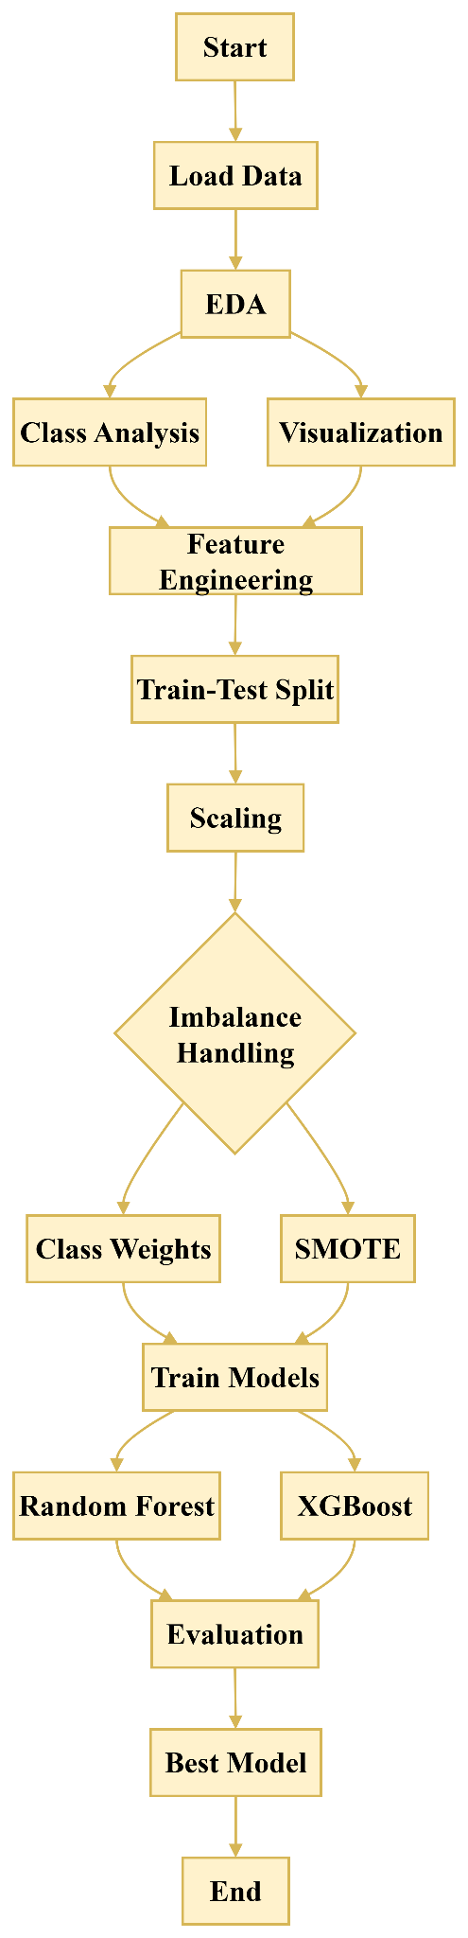

Figure 3.1: Research flow diagram
(Source: Self-developed)
The flow diagram of the research indicates the stepwise and systematic approach to the development of a fraud detection model. It starts with the loading of data and then exploratory data analysis to comprehend patterns and distributions. Class analysis and visualisation is performed in the process of EDA to determine imbalance and feature relations. These lessons inform the feature engineering phase, during which new variables are generated and useless features filtered out. A stratified train-test split is then employed to divide the data and retain the proportions of the classes. Feature scaling is used to normalise the data to improve the model.
Imbalance control is implemented fater this using the weighting class and the SMOTE techniques to handle uneven distribution of classes. This processed data is then inputted into machine learning models, in this case, Random Forest and XGBoost to train them. These models are quantified by appropriate measures of performances in a way that measures their effectiveness. The most effective model is adopted on the basis of the results of evaluation. The end result is the final model that is ready to be implemented in fraud detection.

3.1 Research Design
The study uses a quantitative experimental research design to examine machine learning-based fraud detection techniques. A quantitative experimental research design allows systematic comparison of predictive models based on structured data and quantifiable results (Ebiele et al. 2025). It is specifically appropriate since fraud detection is associated with numeric characteristics and classification methods that involve statistical assessment. The experimental method provides controlled training and testing of models in a consistent environment (Amini et al. 2023). It is also more conducive towards reproducibility in which identical data sets and operations can be employed to check the findings. Performance measures, such as precision and recall and F1-score, are used to improve analytical rigour. The model is suitable considering the intention to find the most suitable model when the data is imbalanced.
A qualitative research design was not chosen since qualitative research looks at subjective knowledge as opposed to the accuracy of numerical predictions. A qualitative method cannot be used to analyse large-scale transaction databases, which must use computational model methods (Mostajabi et al. 2021). On the same note, a mixed-methods approach was not taken because qualitative elements would not make a remarkable contribution to the performance evaluation of the model. The survey-based or interview-based designs were also avoided since they are based on human responses and not on transactional data. A purely descriptive design has been avoided because it does not have the predictive power needed in detecting fraud activities. Thus, the quantitative experimental design can be deemed as the best option in accomplishing the research objectives effectively.

3.2 Data Source and Description
A publicly available credit card transaction dataset from Kaggle is used in the study to obtain this research result. It contains 284,807 transactions having 31 features like anonymised variables and transaction attributes. In order to maintain privacy, each variable in the dataset is coded with the help of principal component transformed variables, which are denoted by V1 to V28. The time of transaction, the volume of transaction and a binary property of a fraudulent or non fraudulent nature are other characteristics. The anonymisation assures a provision of privacy protection using significant patterns that can be analysed using machine learning (Gadotti et al. 2024). The size and heterogeneity of the dataset serve to achieve the objective of the classification models testing under realistic conditions. The difference between fraud and legitimate transactions is being determined by the target variable, which is the basis of supervised learning. Attributes are numeric to allow their direct application in machine learning algorithms, without necessarily encoding them categorically. The dataset structure enables efficient training, validation and testing of predictive modelling activities. Thus, it offers a robust foundation to the discussion of imbalanced data problems in credit card fraud detection.

3.3 Data Analysis
This research employed the Python programming language to perform data analysis. Python was chosen as it has broad libraries to serve machine learning, data processing and visualisation (Lavanya et al. 2023). It was implemented in the Google Colab platform, which offers an interactive setting in the cloud. Google Colab is a platform that allows computationally intensive models to be executed efficiently without the need to have high-end local hardware resources (Usman et al. 2022). It can also be used with other popular libraries like NumPy, Pandas, and Scikit-learn. Through these tools, the analysis pipeline allows processing large quantities of data efficiently, engineering features, and model evaluation.
The visualisation libraries, such as Matplotlib and Seaborn, were used to generate insights through the extraction of exploratory data analysis. Preprocessing of data included scaling, transforming, and dealing with imbalanced classes via SMOTE methods. Scikit-learn, XGBoost, and LightGBM libraries were used to implement machine learning models in comparison (Theodorakopoulos et al. 2025). The model was validated by stratified k-fold cross-validation in order to give good performance estimates. Every measure of evaluation applied was precision, recall, F1-score, and ROC-AUC, calculated on all the models. It optimised the performance of imbalanced data classification by using the threshold optimisation techniques (Leevy et al. 2023). Therefore, the chosen language and platform were flexible, scalable, and efficient in performing a detailed analysis of data.

3.4 Data Preprocessing
Data preprocessing was a crucial step to guarantee data quality and enhance machine learning performance. Missing values, inconsistencies, and duplicate records were checked in the dataset before analysis. There were no missing values in the dataset, so no imputation methods were needed in preprocessing. The feature engineering was used in transforming the transaction amount based on the logarithmic transformation method (Huang, 2025). This conversion made the skew lower and the distribution of the feature better to be modelled. Also, a time-based feature was added to the model by transforming transaction time into hourly time intervals.
Additional preprocessing included eliminating duplicate characteristics like the original time and amount variables. The data was split into the features of the input and the target feature to be supervised. Standardisation was used in feature scaling to normalise the values of all the variables in a numerical manner (Shantal et al. 2023). The purpose of this was to ensure that all characteristics contribute equally during the model training and avoids large-value bias. The stratified train-test split was used in such a way that there was no disruption to the portioning of the classes in the two datasets. These preprocessing measures promoted consistency of data, efficiency of model performance, and reliability in evaluation of performance.

3.5 Exploratory Data Analysis (EDA)
Exploratory Data Analysis(EDA) was performed in order to get an idea of data patterns, distributions, and associations before building the models.
Dataset Overview:
The data dimensions, feature types, and structure of the dataset were analysed to learn about data composition (Abukmeil et al. 2021).
Class Distribution Analysis:
Fraud and normal transactions were compared, and it created an extreme imbalance where the number of all frauds was minimal.
Visualisation of Class Imbalance:
The superiority of normal transactions was emphasised by pie charts and count plots.
Transaction Amount Analysis:
The distribution of transaction amounts was compared between fraud and normal classes using histograms.
Log Transformation Analysis:
The log transformation was done to minimise skewness in the distributed amount of transactions (Marimuthu et al. 2022).
Time-Based Analysis:
Transaction time was transformed to hours so that the trend of fraud over time could be studied.
Correlation Analysis:
The target variable correlations with features were investigated to determine significant predictors that affect fraud detection.

3.6 Feature Engineering and Data Splitting
In order to accomplish the objective of improving model performance and its predictive capacity, feature engineering was conducted to boost the predictive ability of the dataset. Logarithmic transformation was implemented on the feature of transaction amount in order to decrease skew and stabilise the variance (Obulezi et al. 2025). Also, a new variable, that is a transaction-hour, was formed through the transformation of the original time variable into hourly intervals. This transformation assisted in capturing the time trends connected with fraudulent behaviour. The original features of Time and Amount were dropped to prevent the problem of redundancy and multicollinearity. The engineered features offered more meaningful inputs to machine learning models and enhanced their fraud pattern recognition capabilities.
A stratified train-test method was used to perform data splitting so that the original class distribution could be preserved (Vrigazova, 2021). The dataset was separated into training and test sets, where both datasets would have a proper proportion of fraud. This method is quite necessary when dealing with unequal data, as it avoids bias in the training and testing of models. Model development and validation with the training set was followed by final performance evaluation with the testing set.

3.7 Machine Learning Models
Several machine learning models were created in an effort to decide which fraudulent transactions were likely to be detected and which predictive performance to compare effectively.
Logistic Regression:
Initial performance of fraud classification was done through a baseline linear model that had weighted classes.
Random Forest:
A tree-based model was constructed using an ensemble with class balancing to enhance the strength and accuracy.
Support Vector Machine (SVM):
In order to manage imbalanced classification, SVM has been used with probability estimation and class weights (Bakirarar and Elhan, 2023).
Gradient Boosting:
Complex patterns were captured using a boosting model, but the performance was relatively average.
XGBoost:
A complex gradient boosting algorithm was adopted, where scale_pos_weight was used as a way of dealing with class imbalance (Ayodele, 2023).
Random Forest with SMOTE:
At training, SMOTE was used to equalise the training data before the training of the Random Forest model.
Ensemble Model (Voting Classifier):
A combination of Random Forest and XGBoost, based on soft voting, increased overall predictive performance (Chithuloori and Kim, 2025).
The models allowed the complete comparison and choice of the most suitable approach to fraud detection.

3.8 Model Evaluation Metrics
Model evaluation metrics were calculated based on the measures which are appropriate in cases of extremely dissimilar classification problems. The accuracy was not given the focus due to its possibility of being misleading, where the majority class takes over the predictions. The proportion of the correctly predicted fraudulent transactions of the total number of predicted frauds was measured with precision. The concept of recall was regarded as critical, the ability to recognise actual fraud cases correctly. Precision and recall were balanced using the F1-score to generate a performance measure (George and Srividhya, 2022). Also, the ROC-AUC score was used to assess the model's ability to distinguish between classes at a given threshold. Precision-Recall AUC was also used because it is more informative when dealing with imbalanced data (Shang et al. 2023). The confusion matrices were examined to comprehend true positives, false positives, true negatives, and false negatives, which allowed to assess the model performance in detail. Therefore, these metrics were beneficial for the research to compare the accuracy of all the models and select the best model.

3.9 Reliability and Validity
The data set used in this research is quite reliable because it is large and all features in it are in a consistent structure. It comprises of over 2000,000 transactions which is sufficient to train and test a stable model. The absence of any missing values and a standardised number format also contribute to data reliability and consistency. The validity of the dataset is that it can be used because of its real-life sources that are some of the real patterns of credit card transactions and fraudulent activities. The use of anonymised features preserves privacy and meaningful relationships to be analysed. In addition, appropriate preprocessing and stratified sampling procedures ensure a representation of the result according to the involved data distribution.

3.10 Advantages and Limitations of Methodology
Aspect | Advantages | Limitations
Data Handling | Massive data guarantees a strong training and cost-effective model testing outcomes. | The data is extremely unbalanced, and this can lead the models to predict the majority classes.
Preprocessing | Scaling and transformation of features enhance both the model performance and data consistency (Ahsan et al. 2021). | The use of log transformation can inhibit the interpretability of the original values of the transaction amount.
Imbalance Handling | Techniques such as class weighting or SMOTE enhance minority classes detection. | There are chances of synthetic noise created by SMOTE and the possibility of overfitting.
Model Selection | Multiple machine learning models allow a comprehensive comparison and selection of the best performer. | Complex models increase computational cost and lead to lower interpretability of results (ElShawi et al. 2021).
Validation | The stratified cross-validation guarantees the reliability and non-bias in the model performance evaluation. | The cost of cross-validation is higher, particularly when using large datasets and when cross-validating a large number of models (Allgaier and Pryss, 2024).
Evaluation Metrics | Precision, recall and F1-score are used to enhance accuracy in the evaluation of fraud detection. | The interpretation of metrics can be complicated with non-technical stakeholders or decision-makers.

Table 3.1: Advantages and limitations of machine learning models
(Source: Self-developed)

3.11 Ethical Considerations
This study adheres to the ethical considerations that ensured that data and procedures were employed in a responsible manner. This was grounded on publicly available, anonymised credit card account transaction data, eliminating the chances of personal identification. No personal identifiating data were accessed and data protection and privacy principles were followed. The data were not collected through formal consent since no direct human subjects were involved. However, the research was carried out according to the principles of confidentiality and the responsible treatment of data in the research. The models were in such a way that they were developed out of pure academic and analytic benefit without any abuse in the real financial systems. Moreover, the bias in the model projections was considered particularly due to the inequalities in the classes. There were also clear and transparent findings to bring credibility and integrity of the research.

4. Chapter 4: Results, Analysis and Evaluation of Findings

4.1 Data Relevancy
The data that has been used in this research is highly relevant in credit card fraud detection. It includes real-world transaction data, which depicts actual financial activity and fraud patterns. The information is confidential but there are no crucial statistical associations that are lost since there are anonymised characteristics. These attributes enable machine learning algorithms to form significant distractions between fraud and a legitimate transaction. It also has attributes of transaction amount and time concerning the dataset, which are vital in identifying any suspicious spending patterns. These features enhance the chances of identifying both temporal and behavioural fraud related abnormalities. Therefore, the dataset provides a strong foundation upon which reliable fraud detection models can be built.
Moreover, the dataset is large, which enhances the generalisability and makes model training and evaluation robust. The aspect of a very skewed class distribution is a close reflection of real-life problems of detecting fraud in financial institutions. This ensures the research findings are more realistic and functional in actual operational settings. The structure of data, which is purely numerical features, permits smooth incorporation into machine learning algorithms. Moreover, preprocessing methods like feature engineering and scaling improve the quality of data and its relevance in analysis (Shahidi et al. 2025). Therefore, the dataset is proper, legitimate and suitable to pursue the research objectives.

4.2 Reliability and Validity of the Source
The research source of the current data is the Kaggle platform, which is well known for its trusted data sets. Kaggle offers curated datasets that are donated by scientists, organisations and practitioners, which guarantee a reasonable degree of trust and quality. Credit card fraud data used in this research have been widely used in studies and other applications in the industry. Its recurrence in previous research studies makes it more believable that it is reliable and consistent in various applications in analysis. Furthermore, the dataset is well-documented, and the features and structure are clearly described, which promotes correct implementation. Community validation, in the form of discussions and shared notebooks, is also facilitated by the platform, which contributes to the additional reliability of the datasets.
The dataset represents actual behaviour of transaction and fraud in financial systems in terms of validity. Privacy can be ensured via anonymisation of features without any meaningful relationships lost to analyse machine learning (Majeed and Hwang, 2023). This helps in construct validity as it depicts the scenarios of fraud detection accurately. The external validity is also given, with the dataset being close to the actual class imbalance problems. Thus, Kaggle is a credible and appropriate source of data to use in this study.

4.3 Results and Analysis
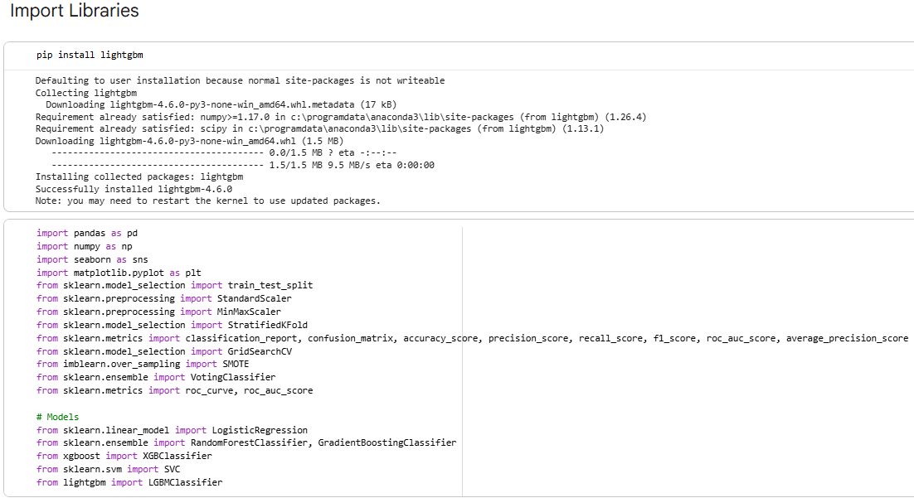

Figure 4.1: Importing necessary libraries
(Source: Developed in the Python environment)
The Python libraries that are imported to perform analysis processes include Pandas, NumPy, Matplotlib, and Seaborn. It also has machine learning libraries such as Scikit-learn, XGBoost, and LightGBM, which can be used to model. These libraries offer the needed tools to preprocess and visualise data and develop predictive models. The presence of LightGBM installation also shows that the workflow resulted in the inclusion of more advanced gradient boosting methods.
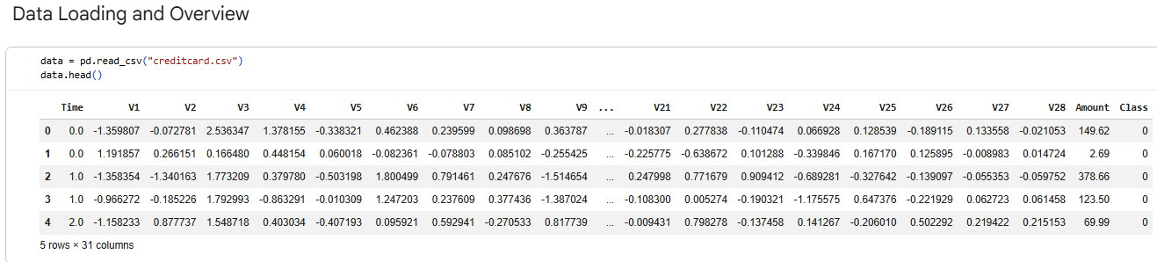

Figure 4.2: Dataset importing and showing the first five rows
(Source: Developed in the Python environment)
The dataset is loaded using a CSV file that contains credit card transactions. An overview of the data reveals that it is numerical with features V1-V28, Time, Amount, and Class. These attributes are anonymised to ensure that sensitive financial information are retained, and important patterns are retained. The target is the class variable and it states whether a transaction is fraud or legitimate. This structure confirms that data is appropriate to supervise binary classification tasks.
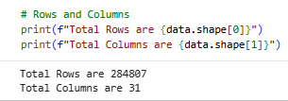

Figure 4.3: Checking number of rows and columns
(Source: Developed in the Python environment)
By proceeding with the analysis, it becomes clear that the data set consists of 284,807 rows and 31 columns. This is a large dataset that enables effective training and stable evaluation of machine learning models.
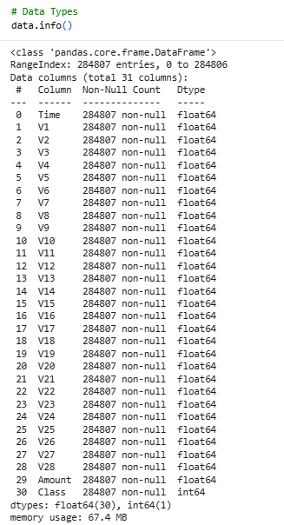

Figure 4.4: Checking information of the columns in the dataset
(Source: Developed in the Python environment)
According to the information provided in the dataset, all the variables are numerical, primarily floats in nature. Class variable is an integer that holds binary classification outcomes in a lucid form. Also, there are no missing values because in all records all columns are filled with entries. The memory usage throughout of approximately 67.4 megabytes suggests that there is efficient storage of a dataset of this magnitude. The absence of categorical variables simplifies preprocessing as there is no need in encoding methodology. Homogeneity of the data type enhances compatibility of the models and reduces the preprocessing complexity (Çetin and Yildiz, 2022).
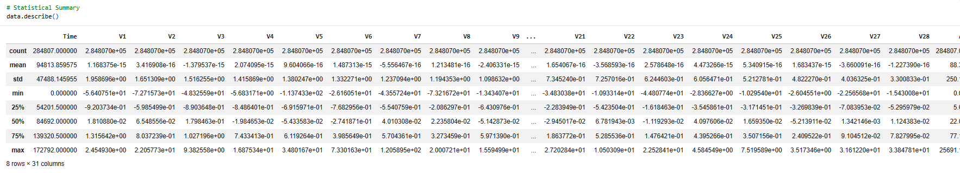

Figure 4.5: Result of descriptive statistics
(Source: Developed in the Python environment)
The descriptive statistics actually show that it was a huge dataset with 284,807 transactions, and it even has a uniform distribution of features. The majority of the anonymised features (V1 to V28) have means near to zero, indicating that they have been normalised or transformed beforehand. The standard deviations are different, which means that there is a variation in the feature variability and importance (Rakrak, 2025). Transaction values are extremely skewed, and the range between the minimum and the maximum values is wide. The target variable exhibits severe imbalance in classes, with a very low average rate of fraud. Therefore, the dataset is perfectly organised, although it needs imbalanced processing methods to be modelled effectively.
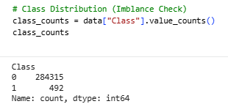

Figure 4.6: Class distribution to check data imbalance
(Source: Developed in the Python environment)
The above image displays the distribution of classes of transactions among the transactions utilised in the analysis. It shows that normal transactions dominate with 284,315 instances, while fraudulent transactions are only 492 cases. This evidently demonstrates a major issue of imbalance in classes in the dataset. This imbalance is characteristic of real-life cases of fraud detection, in which cases of fraud are uncommon. However, such a discrepancy may have a severe impact on the work of a model in case it is not handled appropriately. Machine learning models can be biased to make the majority class prediction. Hence, this observation is the reason that imbalance handling methods like SMOTE and weighting of classes are required.
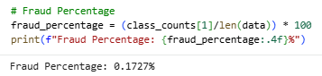

Figure 4.7: Calculating fraud percentage
(Source: Developed in the Python environment)
The above output calculates the percentage of fraud in the data. The fraud rate stands at 0.1727% and is very low compared to the normal transactions. This will verify a data source that will be very biased in respect to the real transaction. Such low probability of fraud makes it hard to categorize, as the models may fail to detect minority cases. It highlights the importance of using the appropriate measures of evaluation, including recall and F1-score, instead of accuracy. This finding also supports threshold tuning to increase sensitivity of fraud detection.
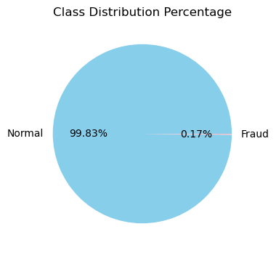

Figure 4.8: Class distribution percentage
(Source: Developed in the Python environment)
The pie chart is used to visually show the percentage of normal and fraudulent transactions in the dataset. About 99.83% are normal transactions, and 0.17% of transactions are fraudulent. The dominance of the majority class is very much apparent, which makes it quite hard for the models to learn the patterns of fraud. This visualisation supports the use of resampling tools and imbalanced-dataset-specific algorithms. It also emphasises the necessity of paying attention to the need to detect minority classes when testing the model.
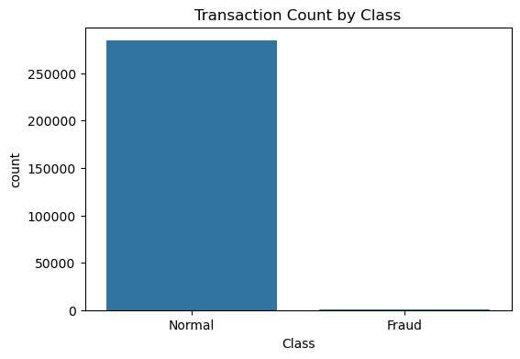

Figure 4.9: Transaction count by class
(Source: Developed in the Python environment)
The number of transactions made in each of the classes is also indicated in the bar chart. It has a high bar that represents normal transactions in relation to the bar that represents fraudulent transactions. This sharp contrast supports the extreme skew in the data. The numerical values alone cannot give a clearer account of the two classes compared to the visualisation provided. It highlights the potentiality of bias prediction within the majority group. This also highlights the importance of pre-processing and model selection.
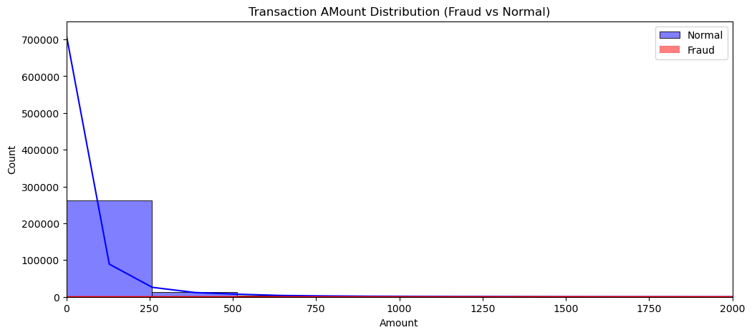

Figure 4.10: Transaction amount distribution (Fraud vs Normal)
(Source: Developed in the Python environment)
This picture depicts the distribution of the amounts of transactions between normal and fraudulent transactions. Most of the transactions lie around lower amounts, where there is a long tail towards higher amounts. The occurrence of fraudulent transactions is much less, but also has a tendency towards a more similar distribution pattern. The skewness of the data shows that the amount of raw transactions may not have a normal distribution. This makes the use of log transformation to normalise the distribution effective. This distribution can be understood to enhance feature engineering and model performance.
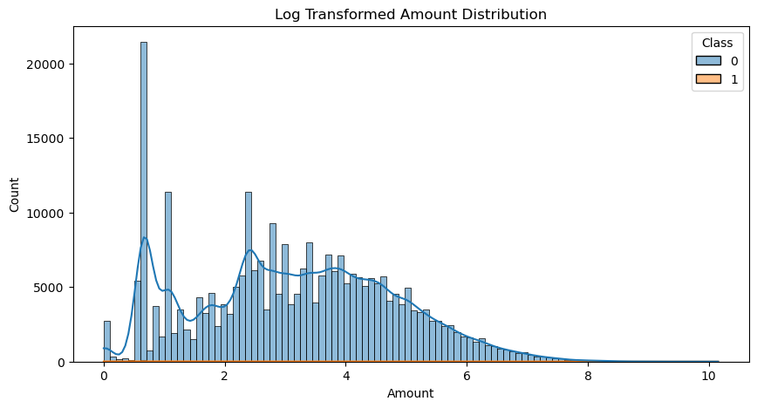

Figure 4.11: Log-transformed amount distribution
(Source: Developed in the Python environment)
The distribution of the number of transactions is made less skewed and more normalised after taking the logarithmic transformation. The log transformation compresses large values and spreads larger values more widely (West, 2022). This enhances the learning capability of machine learning models to learn patterns. Division of normal and fraudulent transactions is a matter that is brought into a little bit of clarity after transformation. This shows that feature engineering can be very effective in improving data quality. It also helps minimise the influence of extreme outliers on model training.
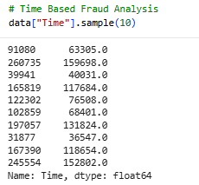

Figure 4.12: Time-based fraud analysis
(Source: Developed in the Python environment)
The output demonstrates an example of the Time feature in the dataset. The values denote seconds elapsed up to the first transaction. The diversity of values suggests that the transactions took place in the long term. This can be used to give some temporal information of the behaviour of transactions. However, raw time values might not be applicable to modelling. This inspires the conversion of time to more significant attributes like hours.
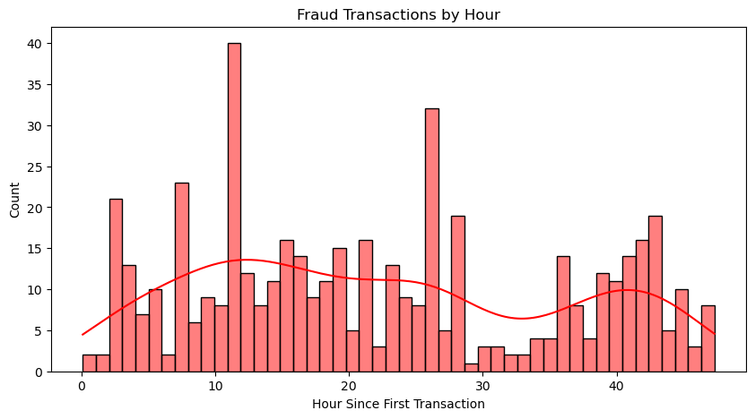

Figure 4.13: Fraud transactions by hour
(Source: Developed in the Python environment)
The histogram shows the distribution of the number of fraudulent transactions during the various hours. The distribution of fraud incidents is distributed throughout the day but exhibits some peaks at certain times. This implies that the incidences of fraud might have a temporal pattern. The recognition of these patterns can enhance model performance by adding time-based characteristics. The visualisation highlights the importance of feature engineering using time-related variables. It provides insights into when fraudulent activities are more likely to occur.
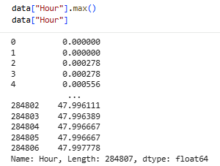

Figure 4.14: Showing the transformation of the hour element
(Source: Developed in the Python environment)
This image illustrates a modified Hour component founded on the Time variable. The values are between 0-48 hours, which is the transaction time. The conversion of time into hours provides greater readable and interpretable data to model. This conversion is useful to represent times in the presence of temporary changes as compared to raw time measures. It also enables more convenient visualisation and analysis of time trends in transactions.
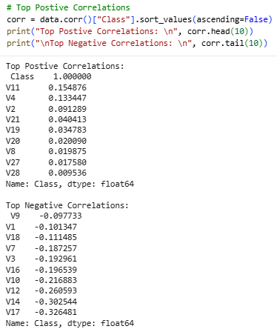

Figure 4.15: Top positive and negative correlations with the class variable
(Source: Developed in the Python environment)
The output helps to determine the features with the strongest positive and negative relationships with the fraud class. Attributes like V11, V4, and V2 have positive associations with the occurrence of fraud. On the other hand, such characteristics as V14, V17, and V12 are strongly negatively correlated. Through these correlations, it can be stated that a good understanding of the variables affecting the detection of fraud. The interpretation of these relations aids in the selection of features and model interpretation. It also guides the development of more effective predictive models.
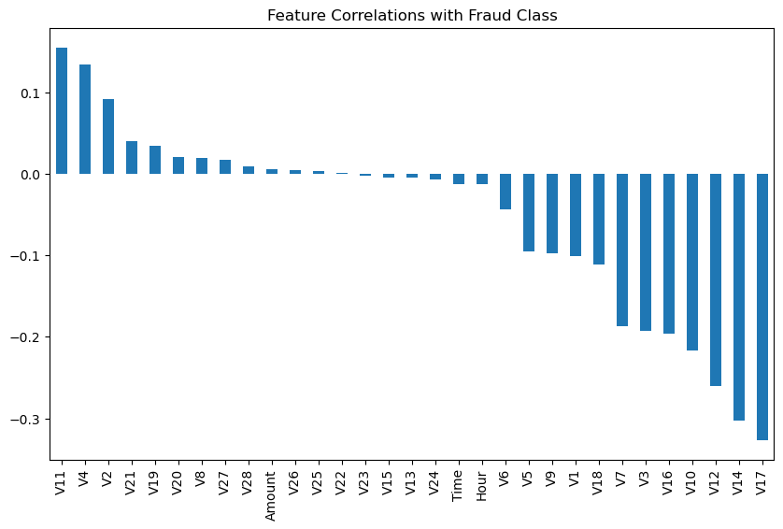

Figure 4.16: Feature correlation with fraud class
(Source: Developed in the Python environment)
The above image visualises the associations between features and the fraud category using a bar chart. It effectively indicates which variables are more related to the target variable. It is easily discernible using the chart whether there are positive or negative correlations. Using this visualisation, it is possible to determine the most significant predictors of fraud. It reinforces the results of the output of the correlation analysis. On the whole, it contributes to the improved knowledge of feature significance and helps to design a better model.
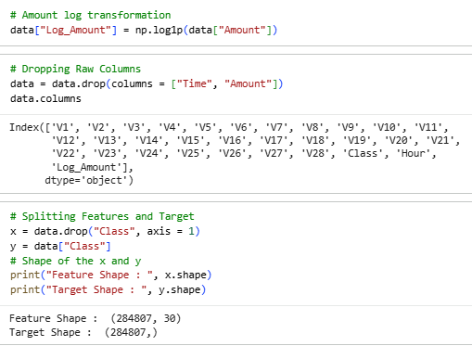

Figure 4.17: Log transformation and splitting the dataset into features and target
(Source: Developed in the Python environment)
The above figure explains the feature engineering and preprocessing actions that were implemented on the dataset. The amount of the transaction is then logarithmically transformed in order to level the skewness and stabilise the variance. This conversion enhances the equalisation of values, which is more compatible with machine learning models. Redundancy and multicollinearity were eschewed by the removal of the original Time and Amount columns after the derivation of the derived features. The dataset is then divided to form features and target variables, in which the label fraud is represented by Class. There are thirty variables in the feature matrix, and there is a target variable with a corresponding class label. The importance of this step is to properly organise the dataset in order to perform the supervised learning tasks and model training.
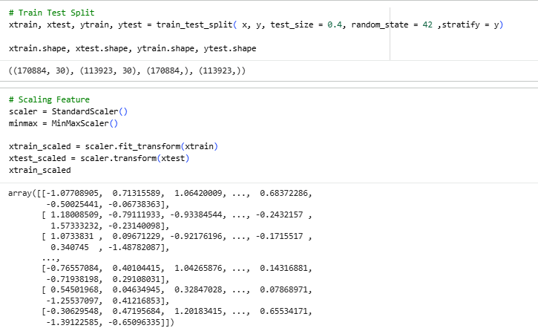

Figure 4.18: Train-test splitting and scaling features implementation
(Source: Developed in the Python environment)
The above image illustrates how data have been divided into training and testing sets in a stratified manner. About 60% of the data is utilised in the process of training, and 40% set aside to test. Stratification allows maintaining the proportions of classes in the two sets, which is necessary in imbalanced datasets. Data are then normalised with the help of standardisation techniques. Data normalisation makes sure that features make an equal contribution in model training and avoids bias based on scale differences (Huang et al. 2023). The scaled data is then presented in the form of numerical arrays, which can be fed into machine learning algorithms.
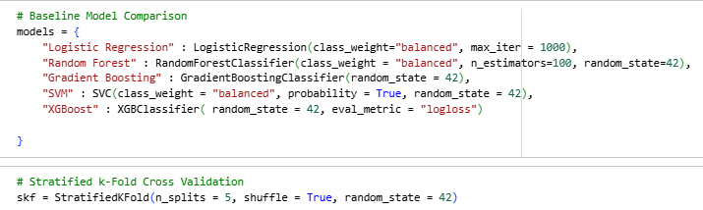

Figure 4.19: Baseline model comparison and stratified k-fold cross-validation
(Source: Developed in the Python environment)
This image depicts the initiation of baseline machine learning models to compare them. There are Logistic Regression, Random Forest, Gradient Boosting, Support Vector Machine and XGBoost models. In order to deal with class imbalance, class weights are assigned to certain models. Stratified k-fold cross-validation is used to evaluate model performance across multiple subsets of the data (Widodo et al. 2022). This is enough to ensure the class distribution is maintained in every fold and improve the quality of the performance estimates. Various models allow approaching the relatively optimal method of development of the most effective fraud detection flow.
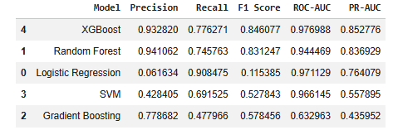

Figure 4.20: Comparison of all baseline models
(Source: Developed in the Python environment)
This image shows a table with performance metrics of each baseline model. XGBoost and Random Forest have excellent behaviour in terms of precision and F1-score. Logistic Regression has high recall and extremely low precision, making it have many false positives. Compared to other models, Support Vector Machine and Gradient Boosting have moderate performance. The ROC-AUC and PR-AUC scores also indicate that tree-based models used in this case are better than linear models. The comparison leads to the significance of the choice of proper models when the dataset is imbalanced, and additional optimisation of the models demonstrating the best performance.
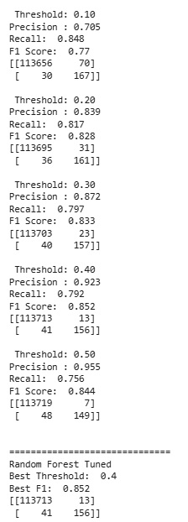

Figure 4.21: Threshold tuning result of the Random Forest Tuned model
(Source: Developed in the Python environment)
This output provides threshold tuning results of the Random Forest model. The probability thresholds are also tested to various values with an aim of providing a trade-off between precision and recall. The higher the threshold, the greater the precision, and the lesser recall, which depicts the trade-off between the two measures. The threshold 0.4 with largest F1-score 0.852 is selected as the best. The confusion matrix shows a more favourable outcome of testing at such a threshold. The step is critical when dealing with imbalanced datasets as default thresholds might not yield the best results. The threshold tuning has the effect of boosting the model efficacy in fraud detection.
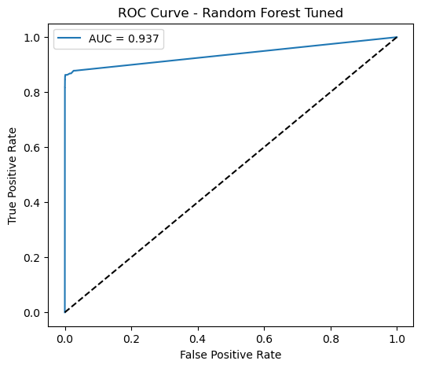

Figure 4.22: ROC curve for the Random Forest Tuned model
(Source: Developed in the Python environment)
The ROC curve of tuned Random Forest model depicts the ability of the model to accomplish the distinction between classes. The model predicts the data well as the curve is extremely above the diagonal line. The AUC score of 0.937 supports the fact that the model has an excellent classification power. The upward curve on the top-left-hand side represents the increase of true positives and a decrease of false positives. This example proves the fact that tuned Random Forest model may be helpful in fraud detection process.
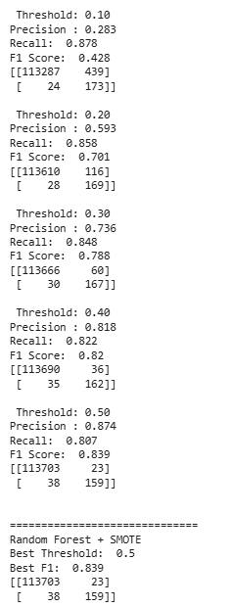

Figure 4.23: Threshold tuning result of the Random Forest + SMOTE model
(Source: Developed in the Python environment)
This output shows the output of threshold tuning tuning when the training data was counterbalanced with SMOTE. The model is higher recalled than the non-SMOTE model which indicates that it has a higher rate of detecting the fraud cases. The optimal threshold is computed and equals 0.5, with an F1-score of 0.839. The model is not so specific, yet more inclined to the recognition of minority classes. This shows that SMOTE can effectively enhance the performance of model with imbalanced dataset.
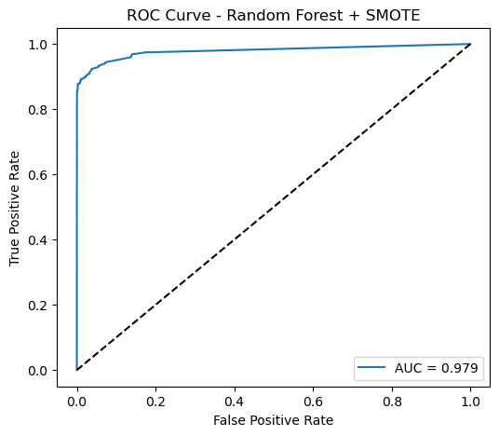

Figure 4.24: ROC curve for the Random Forest + SMOTE model
(Source: Developed in the Python environment)
The ROC curve of the trained Random Forest model using SMOTE demonstrates a great enhancement in performance. The AUC score rises to about 0.979, which means great classification capability. The curve is more centred around the top-left corner than the non-SMOTE model. This shows that balancing the dataset improves the model in a way that it differentiates fraudulent and normal transactions.
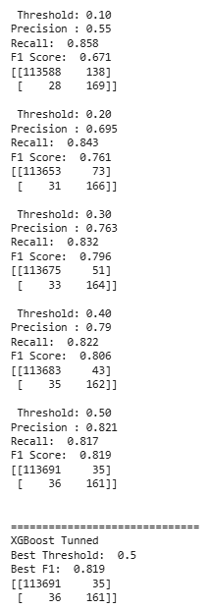

Figure 4.25: Threshold tuning result of the XGBoost Tuned model
(Source: Developed in the Python environment)
This figure shows threshold tuning outcomes of the XGBoost model. Just like other models, higher thresholds lead to greater precision and lower recall. The best threshold is found to be 0.5, and the F1-score is evenly balanced at 0.819. The findings indicate that XGBoost is quite effective in working with imbalanced data with scale_pos_weight. This is needed to make this model optimised in terms of playing the role of detecting any kind of fraud.

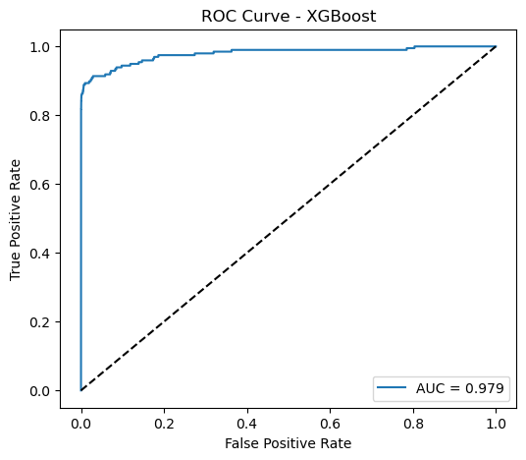

Figure 4.26: ROC curve for the XGBoost model
(Source: Developed in the Python environment)
The XGBoost ROC curve is showing a good classification, and the AUC is equal to 0.979. The curve overlaps the upper left corner implying that the sensitivity and specificity are high. It serves as the confirmation that XGBoost stands great probabilities of success in the task of fraud detection since it is capable of identifying intricate patterns.
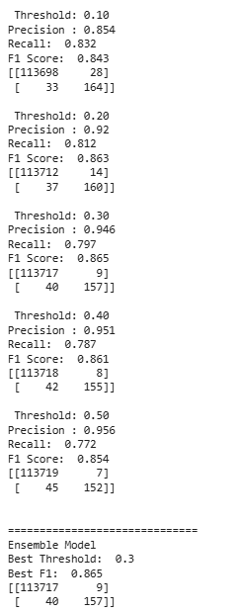

Figure 4.27: Threshold tuning result of the Ensemble model
(Source: Developed in the Python environment)
This figure presents the threshold tuning results of the ensemble model consisting of Random Forest and XGBoost. The threshold that is deemed the best is found as 0.3, where the F1-score is 0.865. The ensemble model shows better precision and balanced recall over individual models. This underscores the role of using an integration of several models in order to improve predictivity.
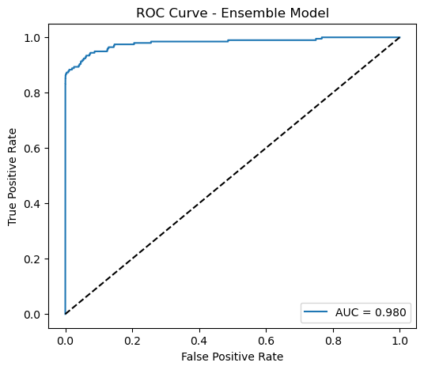

Figure 4.28: ROC curve for the ensemble model
(Source: Developed in the Python environment)
The highest score of an ensemble model ROC curve is approximately 0.980. This demonstrates good performance when compared to individual models. The curve has already been found to remain always higher than rest, which justifies the efficacy of fraud detection with the help of ensemble learning.
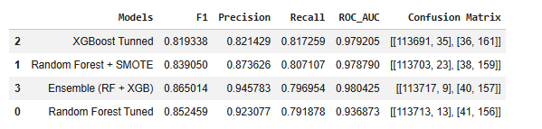

Figure 4.29: Comparison table for all final models
(Source: Developed in the Python environment)
The table is a comparative one on the performance metrics of all final models. The ensemble model holds the top F1-score and ROC-AUC, closely followed by the Random Forest with SMOTE and XGBoost. This comparison offers a perfect overview of model behaviour and aids in making selections.
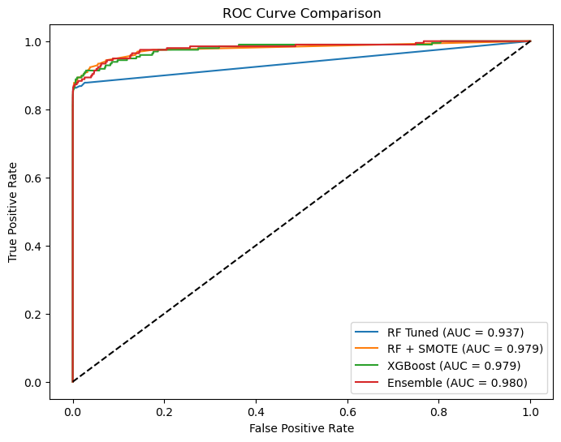

Figure 4.30: ROC curve comparison
(Source: Developed in the Python environment)
This picture is a comparison of the ROC curves of all the significant models. The ensemble model has the highest level of performance, with SMOTE-based Random Forest and XGBoost coming next. The tuned Random Forest without SMOTE performs relatively lower. The effect of imbalance treatment and model choice is also emphasised in this visualisation.
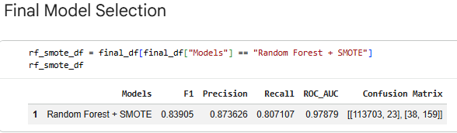

Figure 4.31: Final model selection
(Source: Developed in the Python environment)
The identified model output is the chosen model, which is Random Forest with SMOTE. This choice is made to ensure a balanced performance of precision, recall, and F1-score. Random Forest with SMOTE is a good combination of performance and simplicity, though the ensemble model works a bit better.
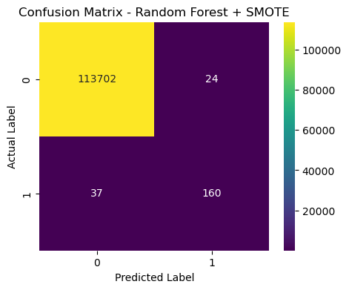

Figure 4.32: Confusion matrix for the final selected model (Random Forest + SMOTE)
(Source: Developed in the Python environment)
The model selected confusion matrix shows a large number of true negatives and true positives. This model works accurately on most of the normal transactions, also they can tell a high number of cases of fraud. There is a relatively low level of false positives and false negatives meaning that the model is effective. This confirms that the model adopted can be applied in the practical implementation of fraud detection.

4.4 Key Findings
The analysis revealed that one of the most significant difficulties in credit card fraud detection is extreme class imbalance. Less than 1% of the total observations were used in fraudulent transactions, as this represents the actual situation in the real world. This disparity has adverse impacts on model learning since it is not able to properly recognise the cases of minority classes. It became necessary that specialised techniques be used to boost the overall performance of detection and reduce the reliance on the majority prediction of classes.
Significant trends were found to be present in terms of transaction amount, time as well as feature correlation using the exploratory data analysis. The values of transactions were highly skewed thus it had to be transformed logarithmically so as to improve the data distribution and compatibility of the model. Time-based analysis indicated that fraud cases possess time patterns in different hours. In addition, correlation analysis revealed that there are certain characteristics, which significantly affect the outcome of fraud detection. These findings led to effective feature engineering and improved input of model to the highest level.
The paper has also shown that the model's performance increased significantly following preprocessing methods, such as scaling and feature engineering. It used stratified sampling to ensure that there was a consistent distribution of classes during the training and testing. The use of class weights and SMOTE to balance it greatly enhanced the ability of the model to be sensitive to fraudulent transactions. Models without imbalance control training performed poorly in terms of precision or recall, which are indicative of biased predictions.
Tree-based analytics, including Random Forest or XGBoost, were significantly more successful than linear models over baseline models. The Logistic Regression had high recall but very low precision, which resulted in a high number of false positives. XGBoost and Random Forest have shown a high level of performance in various assessment measures, such as ROC-AUC and F1-score. Hyperparameter adaptation also enhanced the model efficiency and predictive accuracy.
The threshold optimisation was essential in striking an equilibrium between precision and recall in an imbalanced classification problem. The use of decision thresholds enabled more effective control of the aspects of false positives and false negatives in the prediction. The overall performance of ensemble learning based on Random Forest and XGBoost was the best of all the models tested. However, with SMOTE, Random Forest offered a good compromise between performance, simplicity and computational efficiency.
The study as a whole established the fact that the multiplication of preprocessing, imbalance handling, and advanced machine learning techniques enhances the process of fraud detection. The model chosen was highly predictive and correlated with the ability to forecast in the real world of finance. The importance of these findings is the creation of more precise and efficient fraud detection algorithms based on machine learning strategies.

4.5 Discussion on Findings
A high rate of credit card fraud has been caused by the rapid digitalisation of financial systems. Online transactions have increased, and this has made it more complicated and difficult to detect fraud in mobile banking. The use of rule-based systems that are simple to understand and interpret is becoming less effective in identifying the trends of modern fraud. They are inflexible and incapable of detecting the changing pattern of fraudulent activities unless constantly updated manually (Makki et al. 2019). The continual advancement of tools used by fraudsters renders the widespread use of fixed detection systems an inadequate strategy to apply in reality. This has led to existence of machine learning techniques in solving fraud detection problems.
Machine learning approaches have shown high capabilities in the analysis of large volumes of transactions in an efficient and accurate manner. Random Forest and Logistic Regression are two supervised learning techniques with successful predictions of fraud (Dornadula and Geetha, 2019). These models are capable of finding patterns based on historical data as well as classifying transactions. However, they are quite sensitive to the presence of labelled datasets, which may be expensive and time-consuming to find. The unsupervised learning strategies are flexible since they identify anomalies in the absence of labelled data, yet they tend to be less precise and more prone to false positives (Makki et al. 2019). Thus, the selection of the learning method is to be correlated with the availability of data and the purpose of the research.
A major result of the literature is that class imbalance has a strong effect on the performance of fraud detection. In most cases, fraud permeates a minimal percentage of transactions, usually less than a percent (Warghade et al. 2020). The impact of this imbalance is that it generates bias models in favor of the majority group that restrict them in detecting the cases of fraud. Its extreme precision in such instances is misleading because the models may simply ignore cases of minority classes completely. Thus, the use of appropriate evaluation measurements, such as precision, recall, and F1-score, is of particular concern among scientists. The measures provide a more accurate representation of the model performance in the case of unbalanced data.
In order to deal with the issue of class imbalance, different data balancing methods have been put forward and critiqued in the literature. In order to increase the representation of the minority classes, the oversampling tools, especially SMOTE, have been extensively deployed. SMOTE creates synthetic examples that optimise recall and F1-score to increase the performance of fraud detection (Gupta et al. 2023). However, it can bring noise and a risk of an overfitted situation in some cases. Undersampling methods minimise the size of the majority class, enhancing their computational efficiency, but can lead to the loss of useful information (Dornadula and Geetha, 2019). Hybrid methods use a combination of both methods in order to balance the reduction of bias and data preservation (Warghade et al. 2020).
Ensemble and hybrid models have also shown effectiveness in fraud detection systems as emphasised in the literature. Random Forest and Gradient Boosting are examples of ensemble models that consist of multiple models to enhance the accuracy and resilience (Karthik et al. 2022). Such models minimise overfitting, and complex nonlinear relations of transaction data are outlined. The research shows that ensemble models often perform better than individual classifiers in the vast majority of fraud detection scenarios (Wijaya et al. 2024). However, they are more computationally complex, and their understanding is restricted, making real-time execution difficult. Therefore, the literature indicates that scalable, adaptive, and interpretable machine learning solutions are needed to develop effective fraud detection systems.

5. Chapter 5: Conclusions and Recommendations

5.1 Conclusion
The study focused on developing and testing machine learning credit card fraud detection models. This research was aimed at solving the issues related to highly skewed transaction datasets. The results confirm that the imbalance in classes has a great impact on the performance of the model and the accuracy of detection. The percentage of fraudulent transactions is a very small percentage, and detection is a multi-faceted problem of classification. Thus, it is essential to use specialised methods so that fraudulent activity can be identified correctly.
The research established that data-preprocessing and feature engineering are crucial in enhancing model performance. A time-based feature extraction and logarithmic transformation helped to improve data distribution and pattern recognition ability. Exploratory data analysis was helpful towards understanding the behaviour of transactions and trends of fraud. The measures helped enhance the general quality of machine learning model input data.
The findings showed that tree-based and ensemble machine learning models are much more effective than traditional linear models. Random Forest and XGBoost exhibited high precision, recall and F1-score. Ensemble methods also enhanced predictive accuracy by effectively merging many models. However, the complexity of models and computational efficiency should be taken into consideration in practice.
Algorithms to manage imbalances such as SMOTE and class weighting showed a significant improvement in fraud detection. These procedures enhanced the inclusion of minority classes and the sensitivity level of the model to fraudulent transactions. The balance between precision and recall was also enhanced through threshold optimisation, minimising false predictions. This shows the necessity of incorporating different methods in imbalanced datasets in order to be optimal.
The study indicates that to perform effective fraud detection preprocessing, imbalance control, and sophisticated machine learning models are required. The adopted model of the Random Forest with SMOTE was a reliable and effective method of fraud detection. The analysis offers valuable information on the application of scaled and dependable fraud detection mechanisms. The research results can be used to inform financial institutions to undertake appropriate steps to enhance security and reduce financial losses.

5.2 Linking with Objectives
Objective 1
The first objective was to critically review available journal articles about credit card fraud detection and identify gaps in the research. The aim has been fulfilled through an extensive literature review of the traditional approaches, machine learning approaches, and imbalance management approaches. The report has highlighted the imperfection of the rule-based system and paid attention to the rising nature of the machine learning model. It also determined major gaps which included a lack of agreement on the best models and balance handling strategies. In addition, uneven evaluation measures in studies were found, which signifies that it is important to have systematic model of experimentation.
Objective 2
The second objective focused on analysing the effects of class imbalance on machine learning model performance. This has been done not only by the knowledge of literature but also by analysing the data based on the dataset. The dataset was highly imbalanced, with fraud accounting for less than 1% of total observations. Experimental evidence validated that imbalance-free training did not result in models balancing their predictions. Imbalanced conditions significantly influenced performance measures like recall and F1-score. This discussion made it clear that class imbalance is a detrimental importance to the performance of fraud detection.
Objective 3
The third objective was to create and contrast different machine learning models to detect fraud. This objective was accomplished by using different models, including: Logistic Regression, Random Forest, Support Vector machine, Gradient Boosting and XGBoost. Moreover, both Random Forest and XGBoost ensemble models were trained to improve the predictive accuracy. The models were trained and validated within a consistent environemnt and could be compared equally. The findings indicated that tree-based and ensemble models were much better than the linear models. This comparison gave a clear insight into the effectiveness of the models in identifying fraudulent transactions.
Objective 4
The fourth objective was to test the performance of the models based on relevant evaluation measures. This was implemented using measures like accuracy, precision, recall, F1-score, ROC-AUC, and PR-AUC. The research has highlighted that accuracy is not sufficient with imbalanced datasets because it may be deceptive. False positives and false negatives were evaluated using precision and recall, and the F1-score was the balanced measure. Visual analysis of the model performance was also undertaken by use of confusion matrices and ROC curves. This elaborate appraisal guaranteed a valid and valuable performance assessment.
Objective 5
The fifth objective was to establish the most effective modelling approach according to empirical results. This was achieved by comparing and evaluating the performance of all the developed models. The highest overall performance was noted with the ensemble model, but the final model is Random Forest with SMOTE. This decision was based on a balance between performance, simplicity, and computational efficiency. The model has a high predictive accuracy and realistic usefulness in the detection of fraud.

5.3 Limitations
Aspect | Limitation
Dataset Source | The research is based on one publicly available data set, which restricts extrapolation to other financial systems.
Data Anonymisation | Anonymised (V1 - V28) features minimise interpretability and do not allow real-world interpretation of features.
Class Imbalance | Major imbalance is also difficult, and the resampling method, such as SMOTE, can be a source of artificial noise.
Model Generalisation | Models are trained using historical data, and they might not be able to adjust to changing fraud trends.
Computational Complexity | Advanced models, such as ensemble techniques, increase computational cost and processing time.
Real-Time Applicability | The research deals with offline analysis, which restricts the application in real-time fraud detection systems.
Evaluation Metrics | Although multiple metrics are used, no universally accepted standard exists for fraud detection evaluation.
Feature Engineering | Limited feature engineering may restrict the discovery of deeper behavioural fraud patterns.
External Validity | Findings may not fully represent real-world banking environments with dynamic transaction behaviours.
Interpretability | Complex models such as the XGBoost minimise transparency, making the decision explainability extend to stakeholders.

Table 5.1: Limitations of the research
(Source: Self-developed)

5.4 Future Scope
1. Real-Time Fraud Detection Systems
Future studies may aim to apply machine learning models to real-time settings. This would enable immediate identification of fraudulent activities and enhance financial stability.
2. Advanced Deep Learning Techniques
The neural networks aspect of deep learning and autoencoders aspect of deep learning can be studied further. These models are able to model complex trends and improve precision of detection in skewed data.
3. Hybrid and Adaptive Models
The performance can be enhanced by generating adaptive models that incorporate learning on a continuous basis using transaction data. Supervised and unsupervised learning can also be combined and used to strengthen fraud detection.
4. Improved Imbalance Handling Techniques
Advanced resampling and cost-related learning techniques may be experimented in future research. This has the potential to minimise constraints of SMOTE and enhance minority class forecasting.
5. Explainable AI (XAI)
Transparency and trust in fraud detection systems can be enhanced by incorporating explainable models. This plays a vital role in regulatory compliance and decision-making in financial institutions.
6. Use of Diverse and Real-World Datasets
The additional information provided by various financial institutions can enhance the generalisability of models. This will guarantee enhanced performance in different real-world situations.

5.5 Recommendations
Recommendation 1: Adopting advanced ML models integrated with real-time transaction monitoring systems
The financial institutions are to implement the use of machine learning models and integrated with real-time transaction monitoring systems. Fraud detection accuracy can be enhanced considerably by using random forest models, XGBoost, or ensembles. These models are to be deployed across scalable frameworks, which can handle massive amounts of transactions in real-time. Immediate detection systems allow identifying suspicious activities in real-time and preventing financial losses before transactions are executed. Also, organisations need to maintain operationalised models with new transaction data to be adaptable to changing fraud patterns. Regular retraining of the model would improve the efficiency of the system and keep up with the changing financial conditions.
Recommendation 2: Incorporating robust data preprocessing and imbalance handling techniques
Banking organisations need to incorporate effective preprocessing data management strategies and imbalance management that enhances effectiveness of models. Frauds are rare, datasets have to be balanced with solutions such as SMOTE, class weighting, and hybrid sampling systems. Proper feature engineering, including time based features, and transaction behaviour analysis can enhance predictive capability. It is also recommended that institutions should apply the appropriate evaluation measures such as accuracy which encompasses, precision, recall and F-score instead of paying attention on accuracy. The measures will provide a more accurate insight into efficacy of fraud detection and would reduce the aspect of false positives and negative, enhancing customer experience and operational efficiency.
Recommendation 3: Prioritising explainability, security, and integration when implementing fraud detection systems
When integrating a fraud detection system in a financial institution, explainability, security, and integration should all be considered. Explainable AI methods could assist the stakeholders to comprehend model decisions and create trust in automated systems. It is needed to comply with regulators and transparency of financial activities. In addition, proper data security must also be embraced to protect sensitive financial information during the training of models and their deployment. The detection systems of fraud must be properly linked to the existing banking services, the payment gateways and the transaction processing systems. This offers the capability to apply effectively without disrupting the normal operations and high levels of fraud detection performance.

References
Abukmeil, M., Ferrari, S., Genovese, A., Piuri, V. and Scotti, F., 2021. A survey of unsupervised generative models for exploratory data analysis and representation learning. Acm computing surveys (csur), 54(5), pp.1-40. https://dl.acm.org/doi/pdf/10.1145/3450963
Ahsan, M.M., Mahmud, M.P., Saha, P.K., Gupta, K.D. and Siddique, Z., 2021. Effect of data scaling methods on machine learning algorithms and model performance. Technologies, 9(3), p.52. https://www.mdpi.com/2227-7080/9/3/52
Allgaier, J. and Pryss, R., 2024. Cross-validation visualized: a narrative guide to advanced methods. Machine learning and knowledge extraction, 6(2), pp.1378-1388. https://www.mdpi.com/2504-4990/6/2/65
Amini, M., Sharifani, K. and Rahmani, A., 2023. Machine learning model towards evaluating data gathering methods in manufacturing and mechanical engineering. International Journal of Applied Science and Engineering Research, 15(2023), pp.349-362. https://isireport.org/storage/article-files/apqWqZfthMvW58cXYoV7TEqSsLbNLw9B4CBzc5DR.pdf
Ayodele, A., 2023. A comparative study of ensemble learning techniques for imbalanced classification problems. World Journal of Advanced Research and Reviews, 19(1), pp.1633-1643. https://www.researchgate.net/profile/Adefemi-Ayodele/publication/390727377_A_comparative_study_of_ensemble_learning_techniques_for_imbalanced_classification_problems/links/682869efd1054b0207ef8fa8/A-comparative-study-of-ensemble-learning-techniques-for-imbalanced-classification-problems.pdf
Bakirarar, B. and Elhan, A.H., 2023. Class weighting technique to deal with imbalanced class problem in machine learning: methodological research. Türkiye Klinikleri Biyoistatistik, 15(1), pp.19-29. https://www.researchgate.net/profile/Batuhan-Bakirarar/publication/369458562_Class_Weighting_Technique_to_Deal_with_Imbalanced_Class_Problem_in_Machine_Learning_Methodological_Research/links/641f27e4315dfb4cceaafaee/Class-Weighting-Technique-to-Deal-with-Imbalanced-Class-Problem-in-Machine-Learning-Methodological-Research.pdf
Bello, O. A., Ogundipe, A., Mohammed, D., Adebola, F., & Alonge, O. A. (2023). AI-driven approaches for real-time fraud detection in US financial transactions: Challenges and opportunities. European Journal of Computer Science and Information Technology, 11(6), 84–102.
Breskuvienė, D. and Dzemyda, G., 2024. Enhancing credit card fraud detection: highly imbalanced data case. Journal of Big Data, 11(1), p.182.https://link.springer.com/article/10.1186/s40537-024-01059-5
Çetin, V. and Yıldız, O., 2022. A comprehensive review on data preprocessing techniques in data analysis. Pamukkale Üniversitesi Mühendislik Bilimleri Dergisi, 28(2), pp.299-312. https://dergipark.org.tr/en/download/article-file/2403076
Chithuloori, P. and Kim, J.M., 2025. Soft voting ensemble classifier for liquefaction prediction based on SPT data. Artificial Intelligence Review, 58(8), p.228. https://link.springer.com/content/pdf/10.1007/s10462-025-11230-w.pdf
Dornadula, V.N. and Geetha, S., 2019. Credit card fraud detection using machine learning algorithms. Procedia computer science, 165, pp.631-641. https://www.sciencedirect.com/science/article/pii/S187705092030065X
Du, H., Lv, L., Guo, A. and Wang, H., 2023. AutoEncoder and LightGBM for credit card fraud detection problems. Symmetry, 15(4), p.870. https://www.mdpi.com/2073-8994/15/4/870
Ebiele, M., Bendechache, M. and Brennan, R., 2025. Quantitative data valuation methods: A systematic review and taxonomy. ACM Journal of Data and Information Quality, 17(2), pp.1-39. https://dl.acm.org/doi/pdf/10.1145/3736178
ElShawi, R., Sherif, Y., Al‐Mallah, M. and Sakr, S., 2021. Interpretability in healthcare: A comparative study of local machine learning interpretability techniques. Computational Intelligence, 37(4), pp.1633-1650. https://www.researchgate.net/profile/Radwa-El-Shawi/publication/347161722_Interpretability_in_healthcare_A_comparative_study_of_local_machine_learning_interpretability_techniques/links/61cedd61b8305f7c4b12b33c/Interpretability-in-healthcare-A-comparative-study-of-local-machine-learning-interpretability-techniques.pdf
Faisal, N. A., Nahar, J., Sultana, N., & Mintoo, A. A. (2024). Fraud detection in banking leveraging AI to identify and prevent fraudulent activities in real-time. Journal of Machine Learning, Data Engineering and Data Science, 1(01), 181–197.
Gadotti, A., Rocher, L., Houssiau, F., Creţu, A.M. and De Montjoye, Y.A., 2024. Anonymization: The imperfect science of using data while preserving privacy. Science advances, 10(29), p.eadn7053. https://www.science.org/doi/pdf/10.1126/sciadv.adn7053
George, S. and Srividhya, V., 2022. Performance evaluation of sentiment analysis on balanced and imbalanced dataset using ensemble approach. Indian Journal of Science and Technology, 15(17), pp.790-797. https://sciresol.s3.us-east-2.amazonaws.com/IJST/Articles/2022/Issue-17/IJST-2021-2339.pdf
Gupta, P., Varshney, A., Khan, M.R., Ahmed, R., Shuaib, M. and Alam, S., 2023. Unbalanced credit card fraud detection data: A machine learning-oriented comparative study of balancing techniques. Procedia Computer Science, 218, pp.2575-2584. https://www.sciencedirect.com/science/article/pii/S1877050923002314
Huang, L., Qin, J., Zhou, Y., Zhu, F., Liu, L. and Shao, L., 2023. Normalization techniques in training dnns: Methodology, analysis and application. IEEE transactions on pattern analysis and machine intelligence, 45(8), pp.10173-10196. https://arxiv.org/pdf/2009.12836
Huang, Y., 2025. Enhanced Feature Engineering and Algorithm Optimization for Real-Time Detection of Synthetic Identity Fraud and Money Laundering in Financial Transactions. Journal of Science, Innovation & Social Impact, 1(1), pp.384-397. https://sagespress.com/index.php/JSISI/article/download/43/35
Karthik, V.S.S., Mishra, A. and Reddy, U.S., 2022. Credit card fraud detection by modelling behaviour pattern using hybrid ensemble model. Arabian Journal for Science and Engineering, 47(2), pp.1987-1997. https://link.springer.com/article/10.1007/s13369-021-06147-9
Btoush, E.A.L.M., Zhou, X., Gururajan, R., Chan, K.C. and Alsodi, O., 2025. Enhancing credit card fraud detection with a stacking-based hybrid machine learning approach. PeerJ Computer Science, 11, p.e3007. https://peerj.com/articles/cs-3007/
Khalid, A.R., Owoh, N., Uthmani, O., Ashawa, M., Osamor, J. and Adejoh, J., 2024. Enhancing credit card fraud detection: an ensemble machine learning approach. Big Data and Cognitive Computing, 8(1), p.6. https://www.mdpi.com/2504-2289/8/1/6
Kulatilleke, G. K. (2022). Challenges and complexities in machine learning based credit card fraud detection. arXiv preprint arXiv:2208.10943.
Lavanya, A., Gaurav, L., Sindhuja, S., Seam, H., Joydeep, M., Uppalapati, V., Ali, W. and Sagar, V.S.D., 2023. Assessing the performance of python data visualization libraries: a review. Int. J. Comput. Eng. Res. Trends, 10(1), pp.28-39. https://www.researchgate.net/profile/Lavanya-Addepalli/publication/369533034_Assessing_the_Performance_of_Python_Data_Visualization_Libraries_A_Review/links/6420a158315dfb4cceaee503/Assessing-the-Performance-of-Python-Data-Visualization-Libraries-A-Review.pdf
Leevy, J.L., Johnson, J.M., Hancock, J. and Khoshgoftaar, T.M., 2023. Threshold optimization and random undersampling for imbalanced credit card data. Journal of Big Data, 10(1), p.58. https://link.springer.com/content/pdf/10.1186/s40537-023-00738-z.pdf
Majeed, A. and Hwang, S.O., 2023. Quantifying the vulnerability of attributes for effective privacy preservation using machine learning. IEEE Access, 11, pp.4400-4411. https://ieeexplore.ieee.org/iel7/6287639/6514899/10011406.pdf
Makki, S., Assaghir, Z., Taher, Y., Haque, R., Hacid, M.S. and Zeineddine, H., 2019. An experimental study with imbalanced classification approaches for credit card fraud detection. Ieee Access, 7, pp.93010-93022. https://ieeexplore.ieee.org/abstract/document/8756130/
Marimuthu, S., Mani, T., Sudarsanam, T.D., George, S. and Jeyaseelan, L., 2022. Preferring Box-Cox transformation, instead of log transformation to convert skewed distribution of outcomes to normal in medical research. Clinical Epidemiology and Global Health, 15, p.101043. https://www.sciencedirect.com/science/article/pii/S2213398422000859
Mostajabi, F., Safaei, A.A. and Sahafi, A., 2021. A systematic review of data models for the big data problem. IEEE Access, 9, pp.128889-128904. https://ieeexplore.ieee.org/iel7/6287639/6514899/09537765.pdf
Nadher, I., & Hameed, S. M. (2024). Credit card fraud detection challenges and solutions: A review. Iraqi Journal of Science, 2287–2303.
Obulezi, O.J., Obiora-Ilouno, H.O., Osuji, G.A., Kayid, M. and Balogun, O.S., 2025. A new family of generalized distributions based on logistic-x transformation: sub-model, properties and useful applications. Research in Statistics, 3(1), p.2477232. https://www.tandfonline.com/doi/pdf/10.1080/27684520.2025.2477232
Rakrak, M., 2025. Exploring variability in data: The role of range, variance, and standard deviation. International Journal of Multidisciplinary Research and Analysis, 8(3), pp.1327-1331. https://www.researchgate.net/profile/Mustapha-Rakrak/publication/390127595_INTERNATIONAL_JOURNAL_OF_MULTIDISCIPLINARY_RESEARCH_AND_ANALYSIS_Exploring_Variability_in_Data_The_Role_of_Range_Variance_and_Standard_Deviation/links/67e178c4e2c0ea36cd9bf07b/INTERNATIONAL-JOURNAL-OF-MULTIDISCIPLINARY-RESEARCH-AND-ANALYSIS-Exploring-Variability-in-Data-The-Role-of-Range-Variance-and-Standard-Deviation.pdf
Shahidi, S., Samadzai, A.W. and Shahbazi, H., 2025. Effective Data Preprocessing in Data Science: From Method Selection to Domain-Specific Optimization. Journal of Advanced Computer Knowledge and Algorithms, 2(4), pp.84-90. https://ojs.unimal.ac.id/jacka/article/download/22886/9534
Shang, H., Langlois, J.M., Tsioutsiouliklis, K. and Kang, C., 2023, April. Precision/recall on imbalanced test data. In International Conference on Artificial Intelligence and Statistics (pp. 9879-9891). PMLR. https://proceedings.mlr.press/v206/shang23a/shang23a.pdf
Shantal, M., Othman, Z. and Bakar, A.A., 2023. A novel approach for data feature weighting using correlation coefficients and min–max normalization. Symmetry, 15(12), p.2185. https://www.mdpi.com/2073-8994/15/12/2185
Singh, A., Ranjan, R.K. and Tiwari, A., 2022. Credit card fraud detection under extreme imbalanced data: a comparative study of data-level algorithms. Journal of Experimental & Theoretical Artificial Intelligence, 34(4), pp.571-598. https://www.tandfonline.com/doi/abs/10.1080/0952813X.2021.1907795
Thennakoon, A., Bhagyani, C., Premadasa, S., Mihiranga, S., & Kuruwitaarachchi, N. (2019). Real-time credit card fraud detection using machine learning. In 2019 9th International Conference on Cloud Computing, Data Science & Engineering (Confluence) (pp. 488–493). IEEE.
Theodorakopoulos, L., Theodoropoulou, A., Tsimakis, A. and Halkiopoulos, C., 2025. Big data-driven distributed machine learning for scalable credit card fraud detection using PySpark, XGBoost, and CatBoost. Electronics, 14(9), p.1754. https://www.mdpi.com/2079-9292/14/9/1754
Usman, S., Mehmood, R., Katib, I. and Albeshri, A., 2022. Data locality in high performance computing, big data, and converged systems: An analysis of the cutting edge and a future system architecture. Electronics, 12(1), p.53. https://www.mdpi.com/2079-9292/12/1/53
Vrigazova, B., 2021. The proportion for splitting data into training and test set for the bootstrap in classification problems. Business Systems Research: International Journal of the Society for Advancing Innovation and Research in Economy, 12(1), pp.228-242. https://hrcak.srce.hr/ojs/index.php/bsr/article/download/17347/9337
Warghade, S., Desai, S. and Patil, V., 2020. Credit card fraud detection from imbalanced dataset using machine learning algorithm. International Journal of Computer Trends and Technology, 68(3), pp.22-28. https://www.researchgate.net/profile/Vijaykumar-Patil-3/publication/342391340_Credit_Card_Fraud_Detection_from_Imbalanced_Dataset_Using_Machine_Learning_Algorithm/links/5f29148792851cd302d865b5/Credit-Card-Fraud-Detection-from-Imbalanced-Dataset-Using-Machine-Learning-Algorithm.pdf
West, R.M., 2022. Best practice in statistics: The use of log transformation. Annals of clinical biochemistry, 59(3), pp.162-165. https://journals.sagepub.com/doi/pdf/10.1177/00045632211050531
Widodo, S., Brawijaya, H. and Samudi, S., 2022. Stratified K-fold cross validation optimization on machine learning for prediction. Sinkron: jurnal dan penelitian teknik informatika, 6(4), pp.2407-2414. https://jurnal.polgan.ac.id/index.php/sinkron/article/download/11792/1158
Wijaya, M.G., Pinaringgi, M.F. and Zakiyyah, A.Y., 2024. Comparative analysis of machine learning algorithms and data balancing techniques for credit card fraud detection. Procedia Computer Science, 245, pp.677-688. https://www.sciencedirect.com/science/article/pii/S1877050924031028

